
Power User / Admin Manual




Table of contents
“At RCGT, we do everything possible and put all of our talent into helping high-performing organizations realize their full growth potential.”

1. Maintenance of the Data Model 1
2. Maintenance of the Contributor’s Workflow 34
3. Maintenance of Consolidator’s workflow 57

- Maintenance of the Data Model
  - General
The data model defines the structure of the CCH Tagetik Application and reporting system. For H Grégoire, the data model is as follows:
Consolidation Data Model |  | Original Scenario |  | Actual
Consolidation Data Model |  | Consolidation Scenario |  | Canada Consolidation Scenario  US Consolidation Scenario  International Consolidation Scenario
Consolidation Data Model |  | Periods |  | Monthly
Consolidation Data Model |  | Entity |  | Legal Entities
Consolidation Data Model |  | GL Code |  | Group Chart of Accounts
 |  |  |  | & Statistical Accounts
Consolidation Data Model |  | Var. Det. Types |  | Balance Sheet Movements / Variation
Consolidation Data Model |  | Category |  | $Amount, Pre-Conso Adjustments, Consolidation Adjustments
Consolidation Data Model |  | Currency |  | CAD, USD
Consolidation Data Model |  | Custom Dimension 1 |  | Not in use
Consolidation Data Model |  | Custom Dimension 2 |  | Not in use
Consolidation Data Model |  | Custom Dimension 3 |  | Not in use
Consolidation Data Model |  | Custom Dimension 4 |  | Not in use
Consolidation Data Model |  | Custom Dimension 5 |  | Not in use

Every CCH Tagetik application is based on a multidimensional data model. This is mainly defined by the following
dimensions:
- system dimensions
- custom dimensions
- extended dimensions
- analytical dimensions
In turn, the dimensions can be linked and organized into aggregation structures, allowing them to be analyzed in a functional way. In CCH Tagetik, there are two types of aggregation structures:
- hierarchies
- groupings

In the following sections, we will detail the dimensions set up for H Grégoire as well as how to update the element lists as well as the hierarchies or groupings.

    - Base Elements Management
For every dimension, the user can easily add, delete, or edit an individual or several elements either by using the add, delete, or edit icon or use the built-in feature of quick download and quick upload. The access path is Set-up & Admin > Dimensions
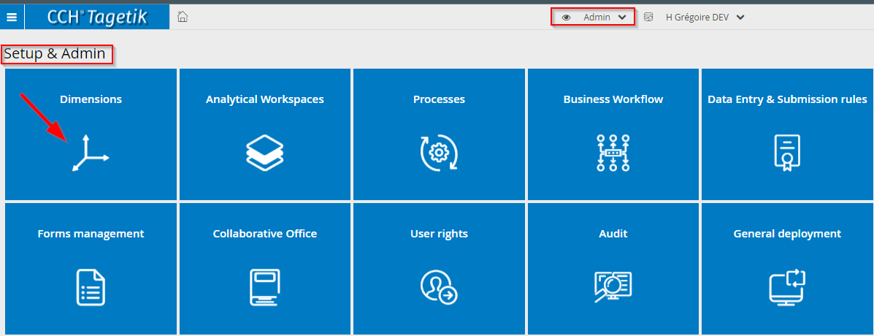
Screenshot 1 - Set-up & Admin > Dimensions
Clicking on “Dimensions” should make the following window to appear, this will be the full list of dimensions used in Tagetik. They can be mandatory dimensions, custom dimensions, or analytical dimensions.
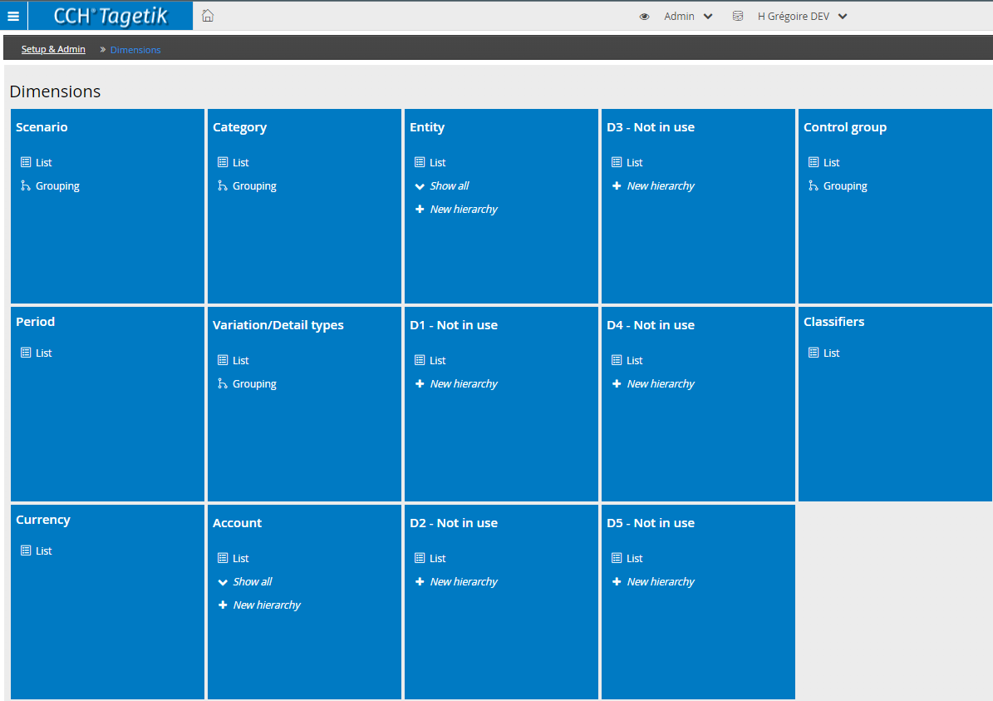
Screenshot 2 - Dimensions List
Each dimension in CCH Tagetik will have a list of base elements and a set number of hierarchies. The base elements will be a flat list of values, for e.g., the list of companies in the consolidation scope.
Each base element of a dimension has:
- Code that is not expected to be changed once set up
- Description that can be changed at any time
- 5 Attributes for Accounts, Entity and custom dimensions
- 10 Attributes for the scenarios
- A list of relevant fields to capture and store information, for e.g., addresses for entity and account type for accounts etc (…)
    - Hierarchies Management
On top of that flat list of values, we can build one or several hierarchies, for e.g., we can have:
- A Regional Hierarchy of Companies
- An Organizational Hierarchy of Companies
However, for the dimensions:
- Scenarios
- Categories
We will have groupings instead of hierarchies. In groupings, there are no restrictions of base elements-node.
Furthermore, the dimensions
- Periods
- Currency
Do not require the configuration of groupings or hierarchies.
In the following sections, we will describe how the mandatory and custom dimensions will be set up for H Grégoire.
    - Financial Statement Template (FST)
For the account dimension, it is also possible to define an aggregation structure other than the hierarchies: The Financial Statement Templates.
An FST represents an ordered set of formulas and headers. In a typical hierarchy, we can only have aggregations of base elements into roll-ups. In an FST, the formulas allow more sophisticated calculations.
Each element that makes up the FST is called an "item" and may be of three types:
- Parent item: are items calculated as the sum of the related individual accounts
- formulas: are items calculated as algebraic formulas (if clauses included): both the items of the same FST and those of other FST
- description
The FST definition is represented by the ordered layout of the items that compose it, by their corresponding attributes and of account -parent items relationships.
The FST is a single-parent structure, namely each account can be related to only one parent item in the FST.
  - Account Dimension
    - Base Elements Management
In the consolidation configuration, the chart of account will be as follows:
Account | Description/Source/Definition
General ledger accounts | This will be comprised of the group chart of account set up by H Grégoire.
KPI and Statistical accounts | Statistical accounts will be added during the build if there is a business requirement for it.
Balance sheet movements | The balance sheet movements will be set up as variation accounts.
      - Add, Delete, Edit an account element
The access path is Set-up & Admin > Dimensions > Account Elements
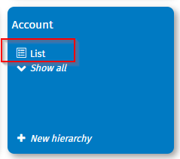
Screenshot 3 - Add Account Element (1)
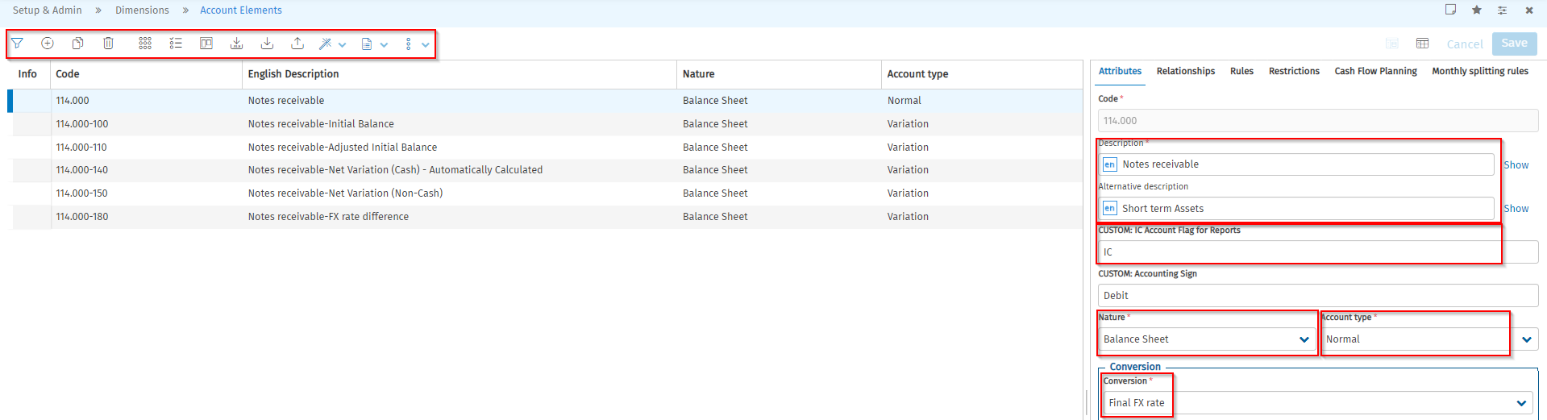
Screenshot 4 - Add Account Element (2)
The icons help the user add, delete, or edit an element.
The enable the user to quick download and export, this is useful when the user must add multiple accounts.
It is not recommended to delete elements as this will trigger the deletion of data associated to that element. The following warning message will guide the user:
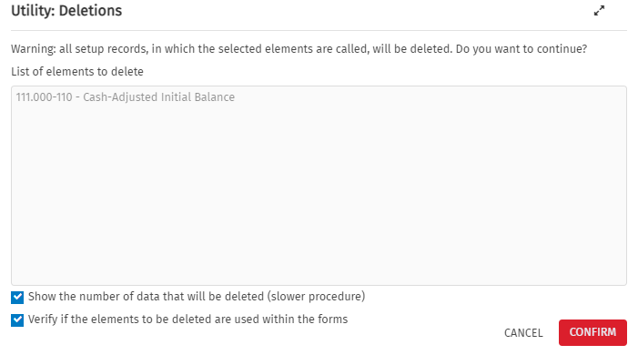
Screenshot 5 - Warning Message upon element deletion
The element description can be changed at any time, the H Grégoire Application has English and French as enabled languages, therefore, it is best practice to add the description in both languages
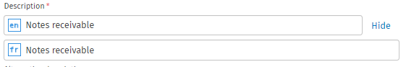
Screenshot 6 - Element Description
For data entry purposes, every account opened to intercompany transaction, an attribute is used to capture that information, therefore that information is required:
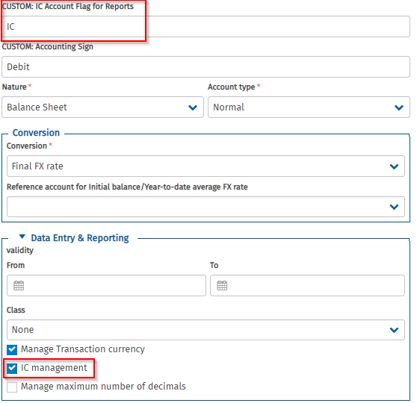
Screenshot 7 - IC Management & IC Attribute
      - Account Nature
The account natures are as follows:
- Balance Sheet nature
- Profit & Loss nature
- No statistical account has been set up.
      - PL Result, BS Result
In addition to the chart of accounts imported from SAP a specific “PL Result” and “BS Result” accounts have been set up. When an entity’s Trial Balance is uploaded, the following will happen:
- The PLRESULT account will be calculated as the sum of all accounts with a P&L nature
- The BSRESULT account will be calculated as (PLRESULT * -1)
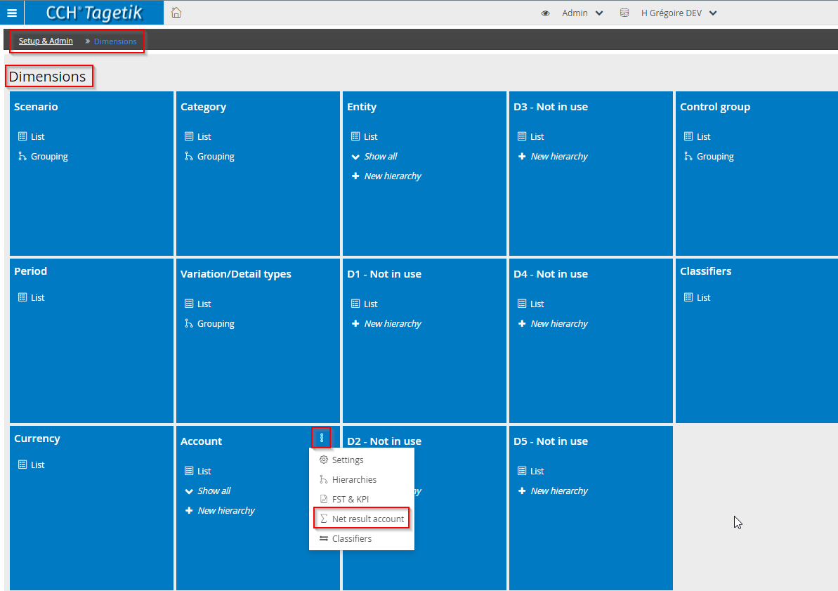
Screenshot 8 - Result Account Set-up (1)
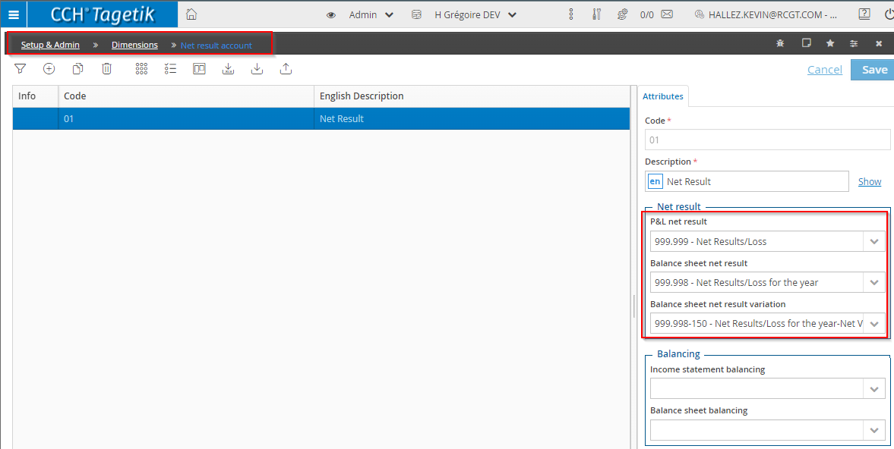
Screenshot 9 - Result Account Set-up (2)
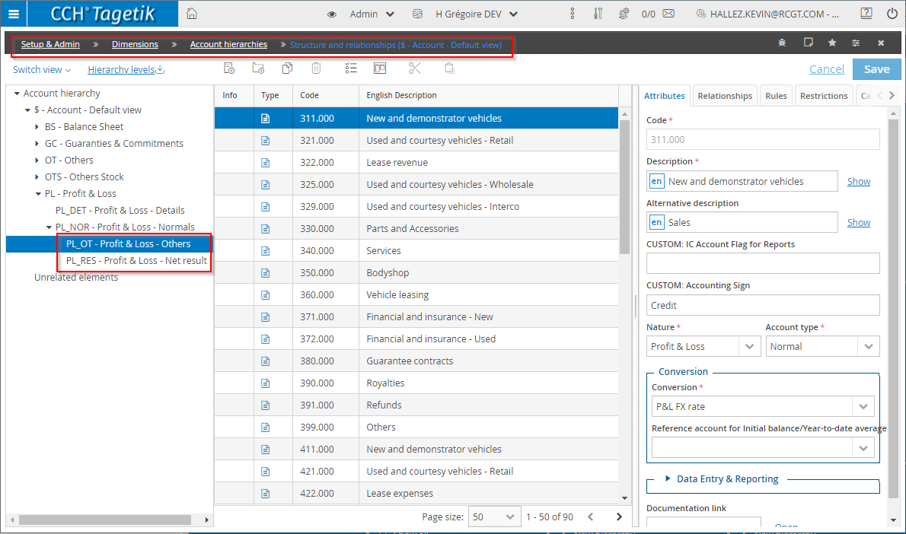
Screenshot 10 - Result Account Set-up (3)
      - Account type
In Tagetik, the chart of account will be comprised of different account types:
Account types
Normal account | Account included in the financial statements.
Detail account | This provides more detailed information than a normal reference account. Usually, detail accounts are used in age reports or subdividing audit fees.  Detail accounts are not used in the carry forward.
Variation account | The variation accounts are used predominantly for the setup of the cashflow as well as the notes. The system also uses the variation account to proceed with the carry forward (roll forward from one scenario to another).
      - Accounts conversion
  - BS conversion: The Bs accounts will be converted with a period Fx rate.
  - P&L conversion: The P&L accounts will be converted with an average P&L rate.

Overridden Fx rates:
In Tagetik you have the possibilities to override the FX rates for specific account:
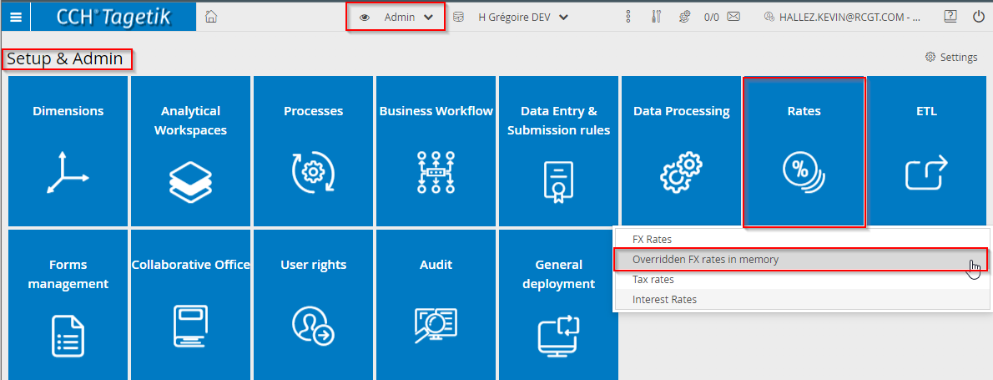
Screenshot 11 - Overridden FX Rates (1)
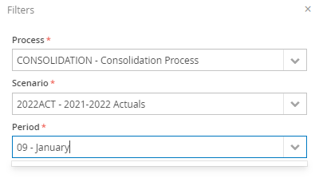
Screenshot 12 - Overridden FX rates (2)
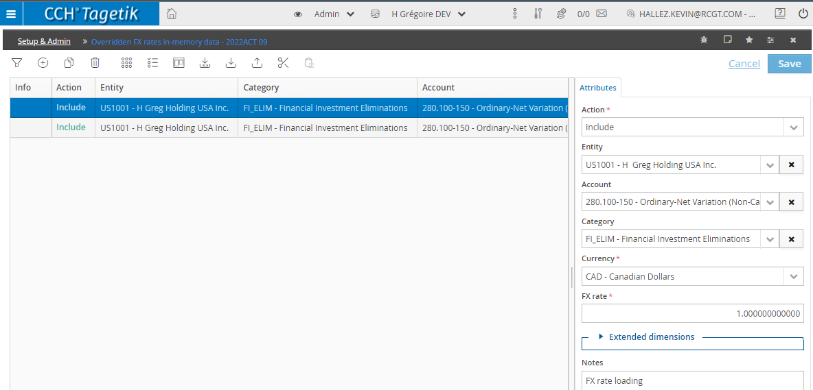
Screenshot 13 - Overridden FX rates (3)

    - 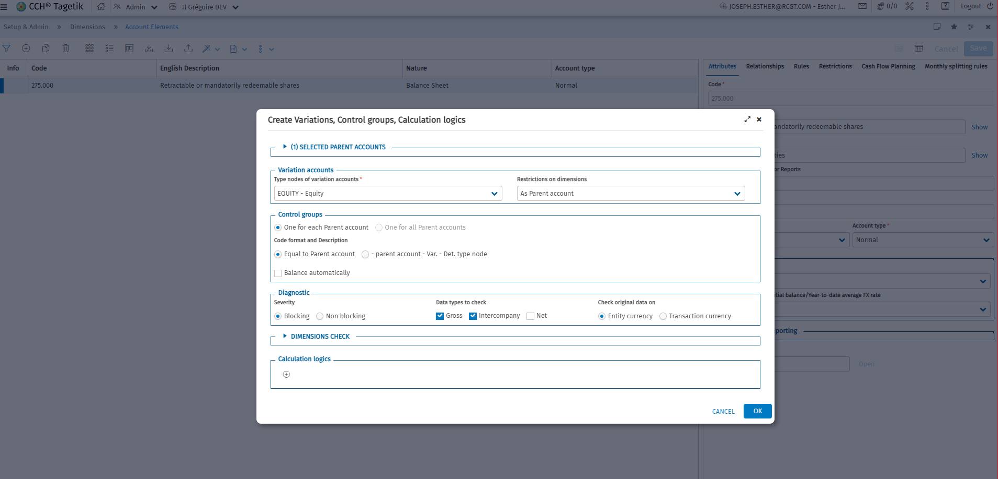Hierarchy Management
The following hierarchies have been set-up for H Grégoire:
Hierarchy Code | English description
$ | Account – Default view
010 | Trial Balance

The access path is Set-up & Admin > Dimensions > Account > Hierarchies
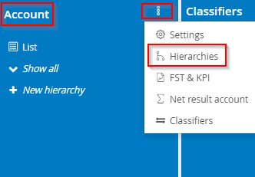
Screenshot 14 - Hierarchies (1)
The following screen should pop-up:
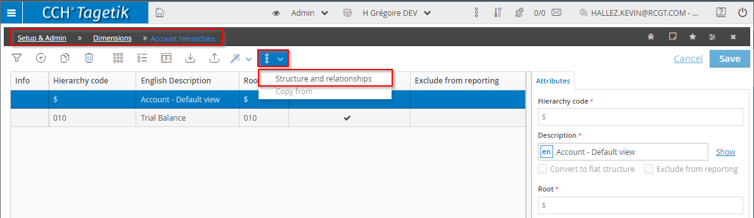
Screenshot 15 - Hierarchies (2)
There is default account hierarchy, generated by the system and coded as “$”. In addition, the user can add as many hierarchies as required.
When the user clicks on “Structure and relationships” the following should pop-up: 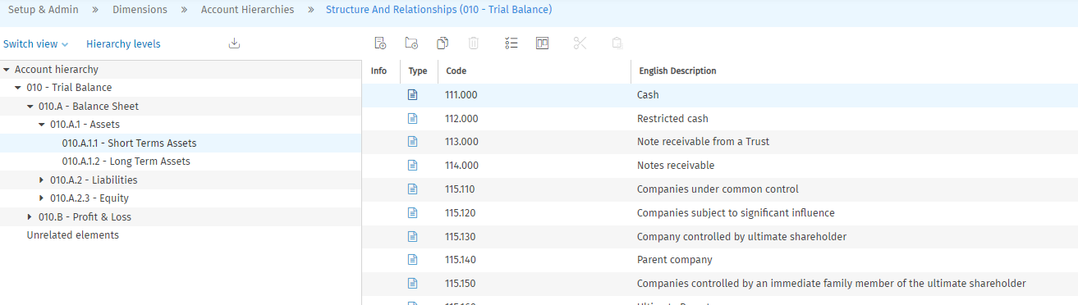
Screenshot 16 - Hierarchies (3)
Add a new node for PL:
- Choose the node PL – Profit & Loss and use the button: Add node:
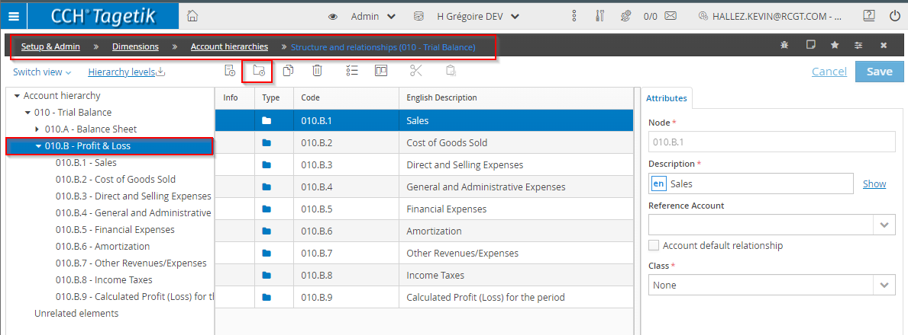
Screenshot 17 - Add a new hierarchy node
- In the right section Attributes, enter the new Code Node and the description:
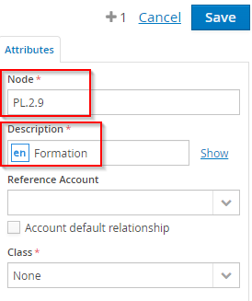
Screenshot 18 - New Node details
Once the node is set up, the user can then add elements by:
  - to that node by dragging and dropping the accounts from unrelated items to the required node
  - using the icons
  - changing the account “Relationships” attributes:
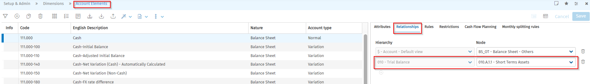
Screenshot 19 - Hierarchy Attributes
It is important to note that an element can only be added to one node.
    - Financial Statement Template (FST)
A financial statement template (FST) is a structure used to aggregate accounts or custom dimensions; FSTs are used to create standard financial statement formats, but also KPIs and other indices that are useful for reporting purposes.
A financial statement template is a hierarchy with two levels:
- the first level includes elements, called FST items; there are three types of FST item:
  - parent item, i.e., this can be related to one or more accounts, as is the case for a hierarchy node. This item shows the sum of the amounts of the relative accounts.
  - formula, defined based on a parent item or on other formulas.
  - description, this does not represent an account but a 'description’ custom header.
- the second level consists of the accounts related to the parent items.
Unlike the case for hierarchies, for financial statement templates it is possible:
- to have ‘formula’ and 'description’ FST items in addition to parent items (which define the concept of grouping nodes)
- to recall FST items from other financial statement templates.
The access path is Set-up & Admin > Dimensions > Account > FST & KPI
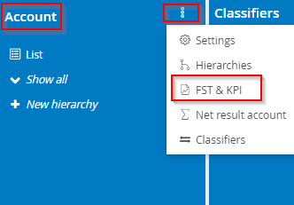
Screenshot 20 - FST (1)
The following should be the window:
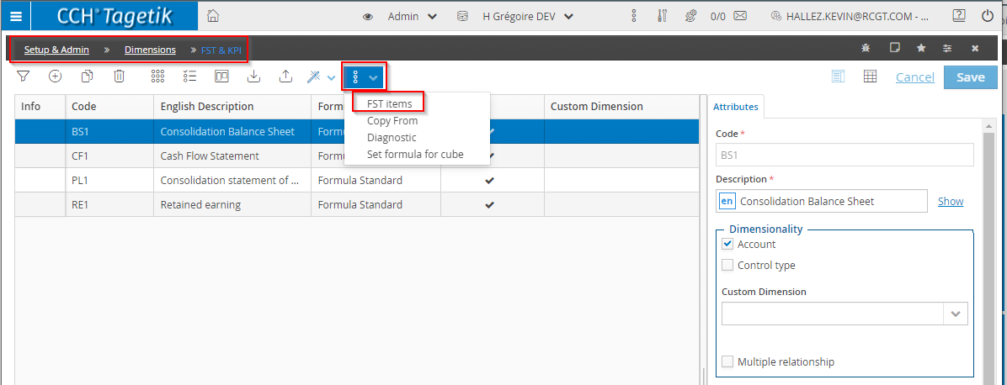
Screenshot 21 - FST (2)
The basic information of the FST is visible here: the code and the description. The user can then drill down to the FST items.
On this window, the user can visualize the FST Items. There several Item type:
  - Parent item: the item may be related to one or more accounts.
  - Description: header line. The purpose of this is to make the content of the template clearer; it cannot be related to accounts.
  - Formula: the FST item is calculated through a formula (standard or multidimensional).
    - Class: Sign with which the amounts are displayed in the reports.
    - Formatting type: Sign with which the amounts are displayed in the reports.
For the FST Items that are “Parent Item”, the user can click on “Relationships” to visualize and update the base element accounts.
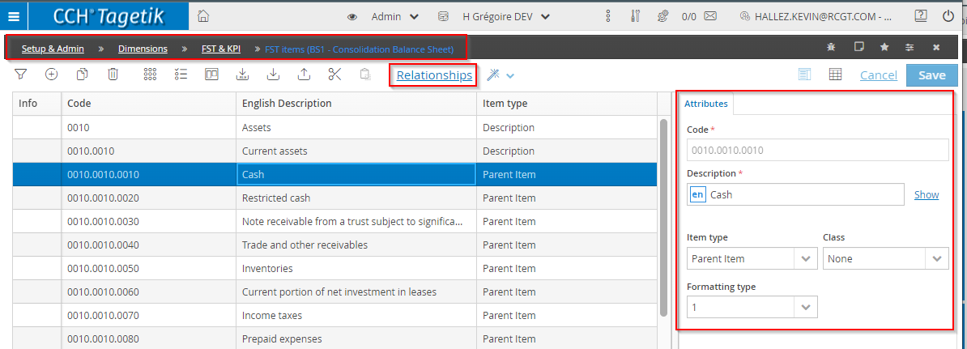
Screenshot 22 - FST (3)
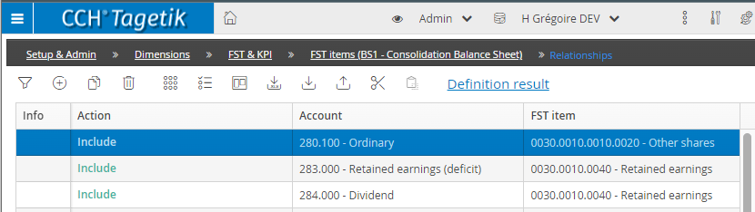
Screenshot 23 - FST (4)
Once the changes are completed, it is advised to run a deployment.
    - Update & Maintenance
It is expected that the update and maintenance will only be manual.
    - Entity Dimension
      - Base Elements Management
The entity dimension (Azienda) refers to the legal and managerial reporting units. The entity dimension, along with Scenario and Period are the dimensions used in defining the workflow. It is also the dimension used to set up the consolidation area.
The update of the elements will be similar to 1.2.1.1.
      - Hierarchies
Hierarchy Code | English description
$ | Entity - Default view
H001 | H Grégoire International Inc.
H002 | Gioia Group

The update of the hierarchies will be similar to 1.2.2
      - Update & Maintenance
It is expected that the update and maintenance will only be manual.
    - Scenario Dimension
      - Base Elements
CCH Tagetik’s Scenario dimension merges the concept of fiscal year (FY) and data version. Each element of the scenario dimension will represent a certain type of data (e.g., Actual, Budget, Forecast) for a given fiscal year.
There are two types of scenarios in CCH Tagetik:
- Original Scenarios refer to the scenario at which unconsolidated data is loaded/entered from the trial balance in the local currency of each entity (Entity Currency)
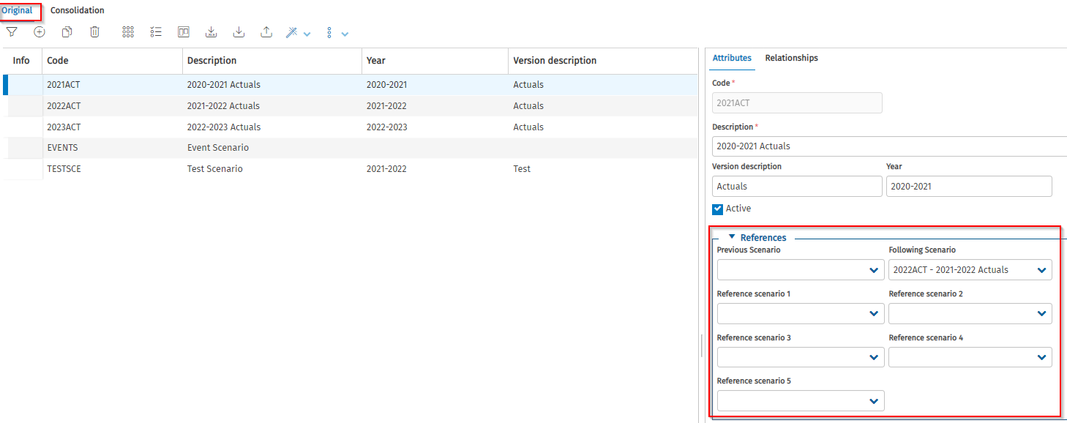
Screenshot 24 - Original Scenario
- Consolidation Scenario is where the currency conversion occurs, and system-generated journals are recorded. One Original Scenario can be related to many Consolidation Scenarios (e.g., one Consolidation Scenario for consolidated values in CAD and another in USD). Consolidation Scenarios contain all the following consolidation specific attributes:
  - Always connected to an Original Scenario
  - Holding Company designation
  - Consolidation Currency
  - Consolidation Scope (which entities are to be consolidated and with which consolidation method for example: line-by-line, equity)
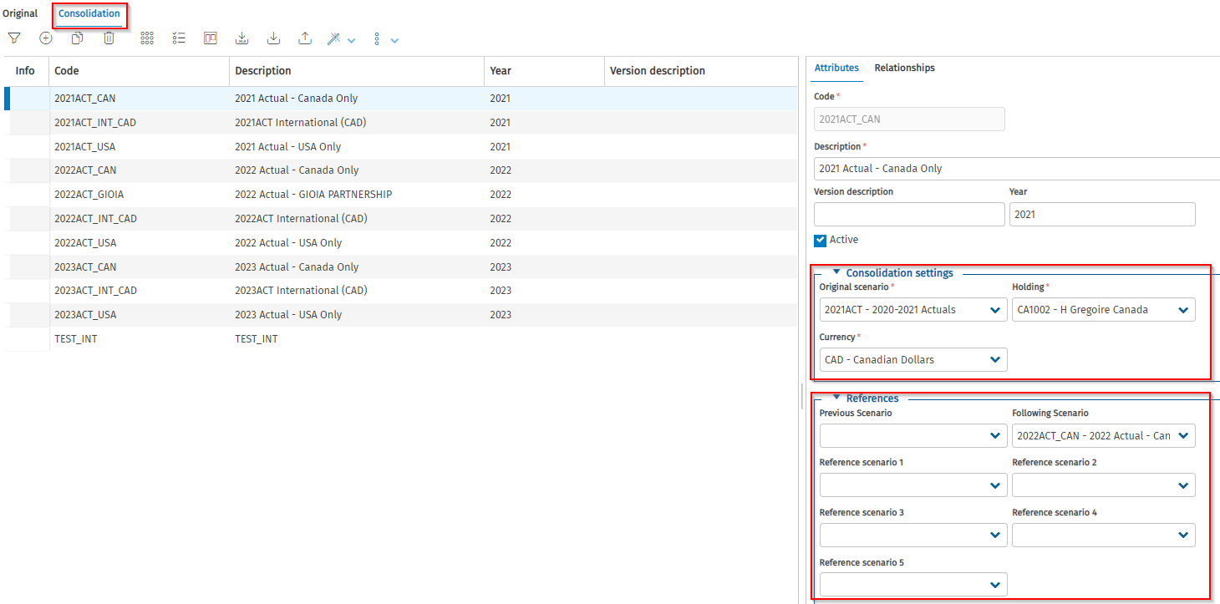
Screenshot 25 - Consolidation Scenario
For each scenario, the user has to ensure that the periods are correctly attached to the scenario and that the period dates are properly set-up:
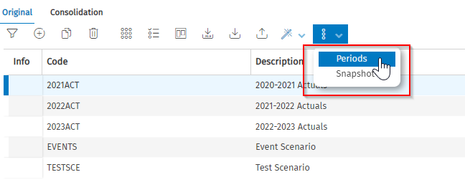
Screenshot 26 - Scenario/Periods (1)
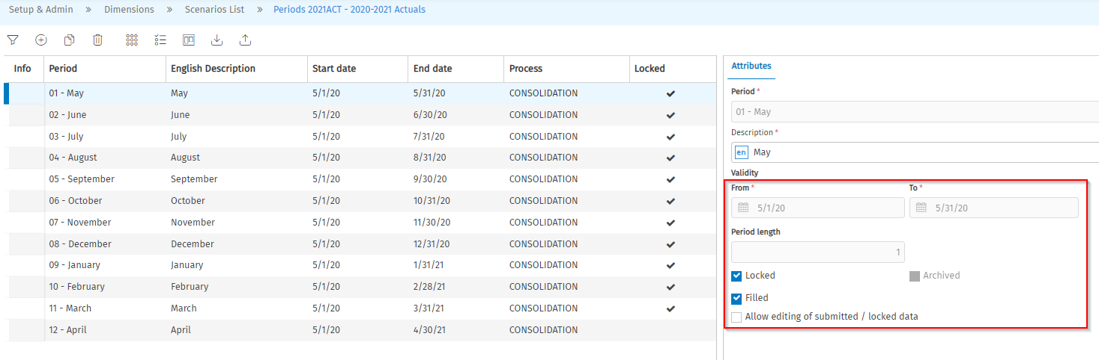
Screenshot 27 - Scenario/Periods (2)
      - Groupings
Groupings are aggregation structures with the following characteristics:
- multi-level structures with unlimited depth, i.e., the elements may be aggregated to different levels.
- multi-parent structures, i.e., each child element in the hierarchy may be related to several parent elements.
- unique structures, i.e., it is possible to create just one grouping for each dimension.
Groupings allow for Category and Scenario dimensions to be aggregated.
    - Update & Maintenance
It is expected that the update and maintenance will only be manual.
    - Period Dimension – no hierarchies
The period represents the method of dividing a fiscal year into periods of time. Normally, a period represents a month, a quarter or half a year.
In the H Grégoire configuration, the period dimension will represent the calendar months:
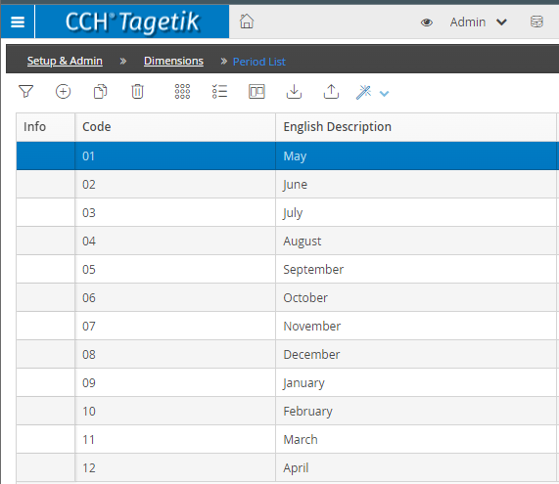
Screenshot 28 - Periods
      - Hierarchies
In this dimension the hierarchy option is not available.
      - Update & Maintenance:
The update and maintenance of the Period will be manual.

    - Currency Dimension – no hierarchies
CCH Tagetik is a multi-currency system and allows the user to manage Amounts in the operation's currency, in the Financial Statement currency and in the Consolidation currency.
The currency list to be added in the H Grégoire configuration is as follows:
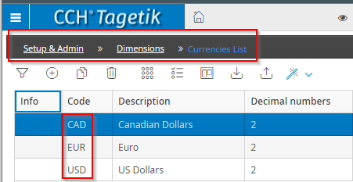
Screenshot 29 - Currencies
      - Hierarchies
In this dimension the hierarchy option is not available.
      - Update & Maintenance
The update and maintenance of the Currencies will be manual.
    - Category Dimension
      - Base Elements
The category is a fundamental dimension of CCH Tagetik since it allows the user to classify and segment data (especially adjustments) and therefore to keep track of the way in which data is generated.
Keeping the data on different categories, allows the user to:
- handle them differently in the Data processing step
- show them separately in the Reports
There are different types of categories in CCH TAGETIK:
  - Amounts: allows the user to classify the original data (Gross amounts and IC figures). CCH Tagetik provides a default Amount category, $AMOUNT. It is possible to use other Amount categories, but more simple cases the default Amount category is enough.
  - Pre consolidation adjustments allows the user to classify the Pre consolidation adjustments, that is the adjustments that represent a modification to the original data to adapt them to the Group's accounting principles
  - Consolidation adjustments: allows the user to classify Consolidation adjustments both manual and automatic ones to be able to analyze each step and create a Reports that show the evolution of the data from the Original to the Consolidated state. The number of these categories vary according to the data segmentation requirements and the complexity of the Consolidation process.
The following categories will be added to the H Grégoire consolidation set up:
Category | Description | Category Type | Description
$Amount | Default Original Amount | Amount | All TB data will be loaded and reported on the $AMOUNT category.
ACCT_POLICY | Account Policy Reclass | Entity journals / Pre consolidation Adjustment | Any reclassification of accounts due to differences in accounting policies can be posted with this category at a pre consolidation level.
RECLASS | Account Reclassification | Entity journals / Pre consolidation Adjustment | The profit elimination will not be automated at this stage, a manual journal entry will be posted with this category.
ENT_ADJ | Other Reclassification/Adjustment |  | Any entity adjustment of accounts can be posted with this category at a pre consolidation level.
PROFIT_ELIM | Profit Elimination | Entity journals / Pre consolidation Adjustment | The Profit Elimination will not be an automatic adjustment, a manual journal entry will be posted with this category.
PPA | Purchase Price Allocation | Entity journals / Pre consolidation Adjustment | The PPA will not be an automatic adjustment, a manual journal entry will be posted with this category.
IC_ELIM | Intercompany Eliminations | Consolidation journals | At the consolidation level, the intercompany transactions will be eliminated, and the adjustment will be posted on this category.
FI_ELIM | Financial Investment Eliminations | Consolidation journals | At the consolidation level, the financial investment transactions will be eliminated, and the adjustment will be posted on this category.
NCI | Non-Controlling Interest | Consolidation journals | At the consolidation level, the non-controlling interest will be eliminated, and the adjustment will be posted on this category.
      - Grouping
CCH Tagetik provides a Predefined aggregation structure having as code$ and three default nodes:
- $AMOUNT: to which is related each new amount category by default
- $PRECO: to which is related each new amount category of Pre consolidation adjustment type by default
- $CONSO: to which is related each new amount category of Consolidation adjustment type by default

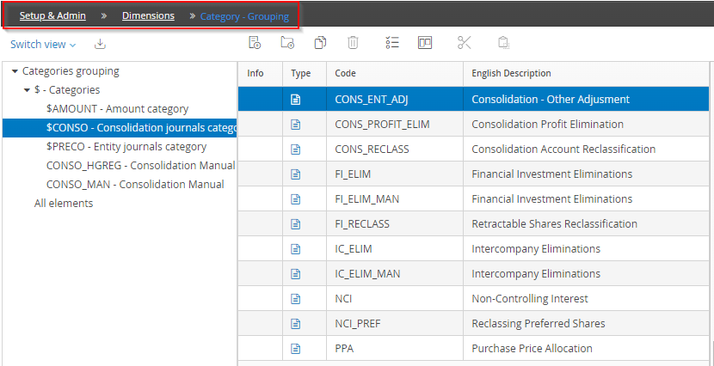
Screenshot 30 - Hierarchy Grouping
      - Update & Maintenance:
The update and maintenance of the Categories will be manual.
    - Control Groups
      - Base Elements
The Control group is a Balancing rule between accounts: the structure that allows the user to create relationships in CCH Tagetik:
- that unifies one or more accounts to its or their details
- that unifies one or more accounts to its or their variations
- or simply, that creates an Equality or Inequality relationship between sets of accounts
Each Control group is made up of two sections:
  - "Parent accounts": contains the list of accounts that should be assigned the detail or the variation
  - "Child accounts": contains the detail or variation accounts that represent the adjustments of the parent accounts
In the case of generic Equality or Inequality relationship between accounts, the concept of Parents and Children should be understood as "First accounts group" and "Second accounts group".
The main function of Control groups is that of checking if inserted data is balanced. Furthermore, via the Control groups, it is possible to generate Calculation rules that:
- calculate the Parent account as the sum of detail/variation accounts. In this case, data insertion is done on detail or variation accounts and the normal account's Amount is obtained as the sum of all its adjustments or details
- calculate one of the detail/variation accounts as the difference between the Parent accounts and their remaining detail/variation accounts
Control groups are generated automatically via the Create System rules utility and are:
- $PL: verifies if the P&L account is balanced (namely, the P&L net result account is equal to the sum of all other P&L normal accounts with sign changed)
- $RESFLOW: verifies if the "BS net result" is equal to "BS net result: variation result of current year"
- $RESULT: verifies if the "BSnet result" equal to " P&Lnet result"
- $BS: verifies if the BS account is balanced (namely, the BS net result account is equal to the sum of all other BS normal accounts with sign changed)
      - Groupings
Groupings are aggregation structures with the following characteristics:
- multi-level structures with unlimited depth, i.e., the elements may be aggregated to different levels
- multi-parent structures, i.e., each child element in the hierarchy may be related to several parent elements
- unique structures, i.e., it is possible to create just one grouping for each dimension

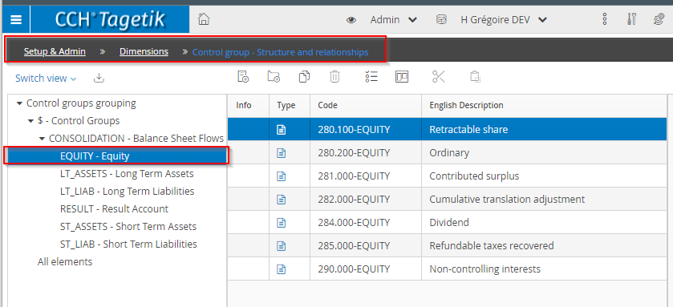
Screenshot 31 - Control Groups
      - Update & Maintenance:
The maintenance will be manual for both the base elements and the groupings.
    - Calculation Logics
Calculation logics are added in the system when data on a particular GL code can be derived via a formula rather than input or uploaded via ETL.
The setup access is Setup & Admin > Data Processing > Calculation Logics
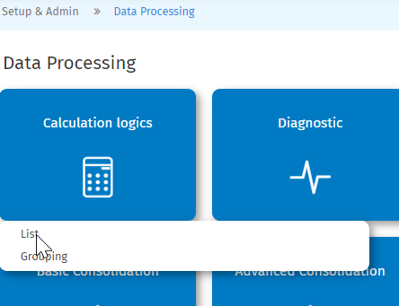
Screenshot 32 - Calculation Logics Path
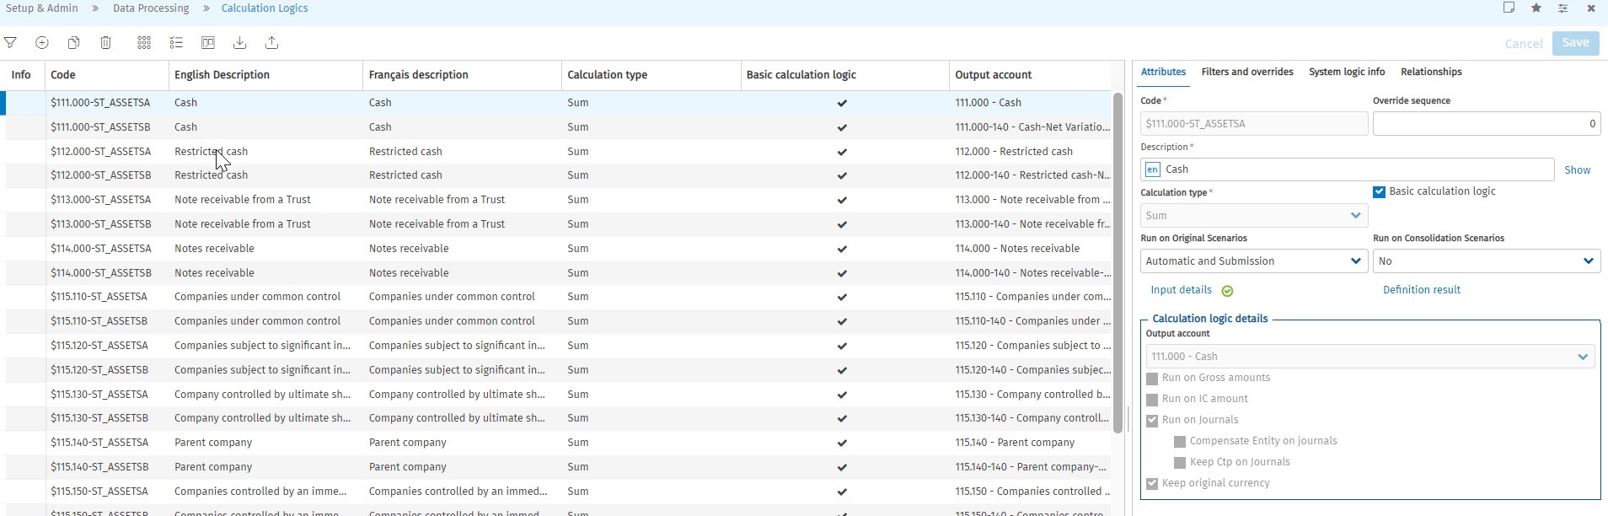
Screenshot 33 - Calculation Logics List
There are several types of calculations:
- Sum
- IC on Gross Amounts
- Net on gross Amount
- Custom MD
Only the Sum are used for H Grégoire. The sum can either be:
- Parent account as sum
- Variation/detail as difference
In most cases, the calculation logics are used to ensure that the normal accounts and variation accounts are always aligned on both TB amount categories and the journal categories.
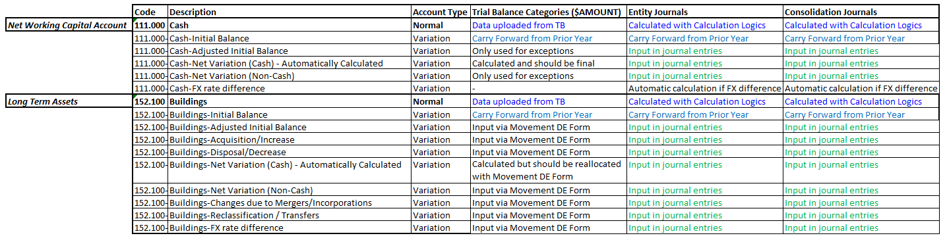
Screenshot 34 - Calculation Logics & Data Flow
      - Account as difference between variations and ending balance
There is a calculation logic “Variation/detail as difference” is set up for every balance sheet account. The calculated variation is the “Net Variation (Cash) - Automatically Calculated”. The calculation only run on gross amounts data and IC amounts, meaning it only works with the $AMOUNT categories.
      - Account as sum for journals
There is a calculation logic “Parent account as sum” for every balance sheet accounts. The calculation only runs on journals as we expect all journals – manual or generated by the system to write on variation accounts.
      - PL Result & BS Result
There is also calculation logics run to calculate the Profit/Loss of the Period and the Balance Sheet Result of the period as described in section 1.2.1.3.
    - Business workflow set-up
For the consolidation process, there is a business workflow set up.
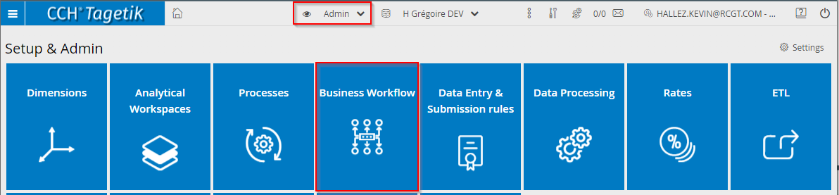
Screenshot 35 - Workflow setup
The workflow has three steps:
- Admin Tasks
- The contributor step
- The consolidation step

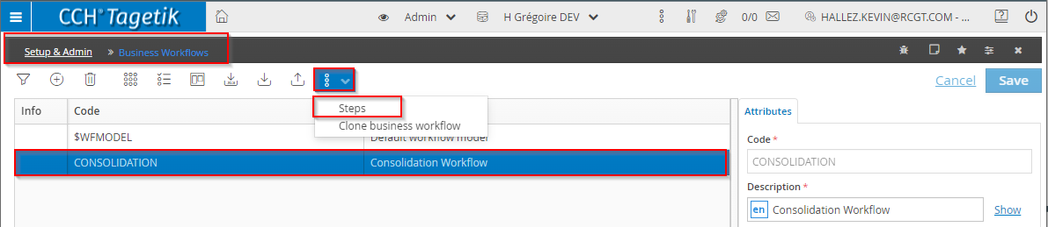
Screenshot 36 - Workflow steps
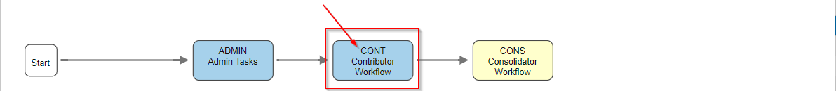
Screenshot 37 - Workflow Steps (2)
In every step, there are tasks organized in a fashion that will facilitate the navigation for the end-user. There are three Task list to make sure that the right ETL is attached to the right workflow.
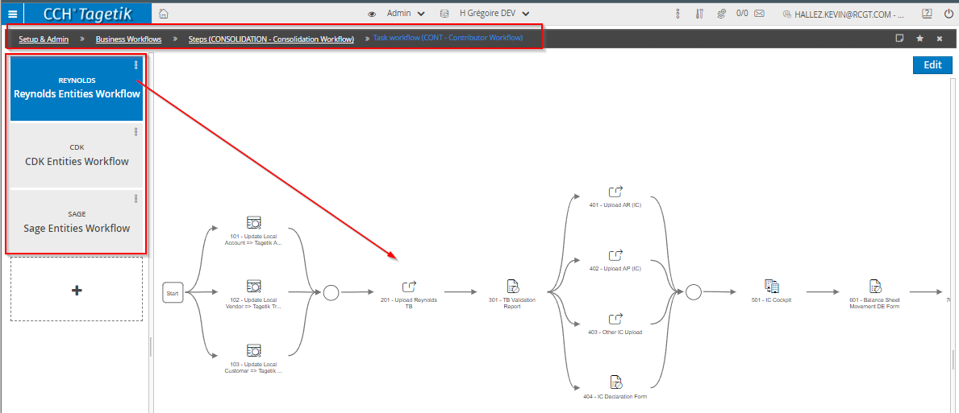
Screenshot 38 - Workflow tasks

  - Tagetik Process
The Process is the basic component of the Tagetik's implementations since it manages all the data entry activities and the automatic data processing.
A Process can be defined as a set of activities or tasks (workflow model) having a start date and an end date and which:
- Includes an authorization workflow of inserted data (organization hierarchy)
- can require a logical functional workflow of the activities to be performed (for example data loading, data processing run, adjustments insertion, submission...)
- works on the whole data model or on its subsets (process data model)
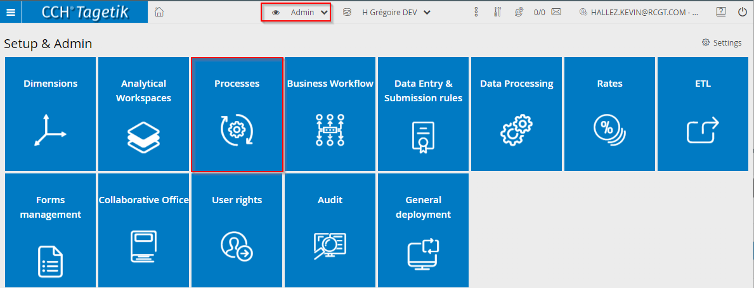
Screenshot 39 - Tagetik Process (1)
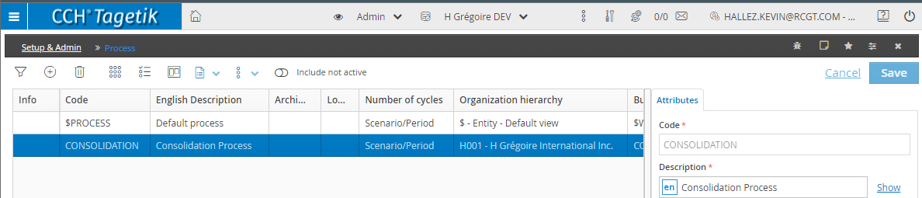
Screenshot 40 - Tagetik Process (2)
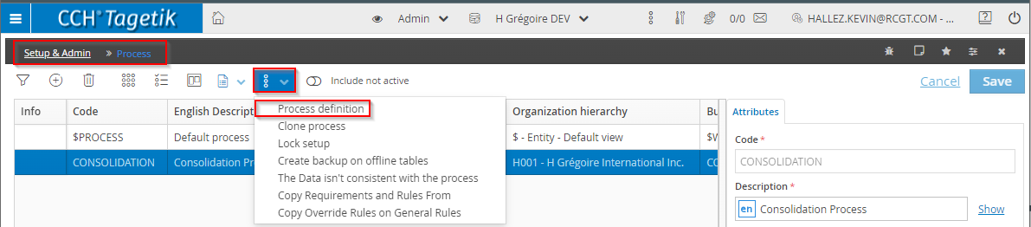
Screenshot 41 - Tagetik Process (3)
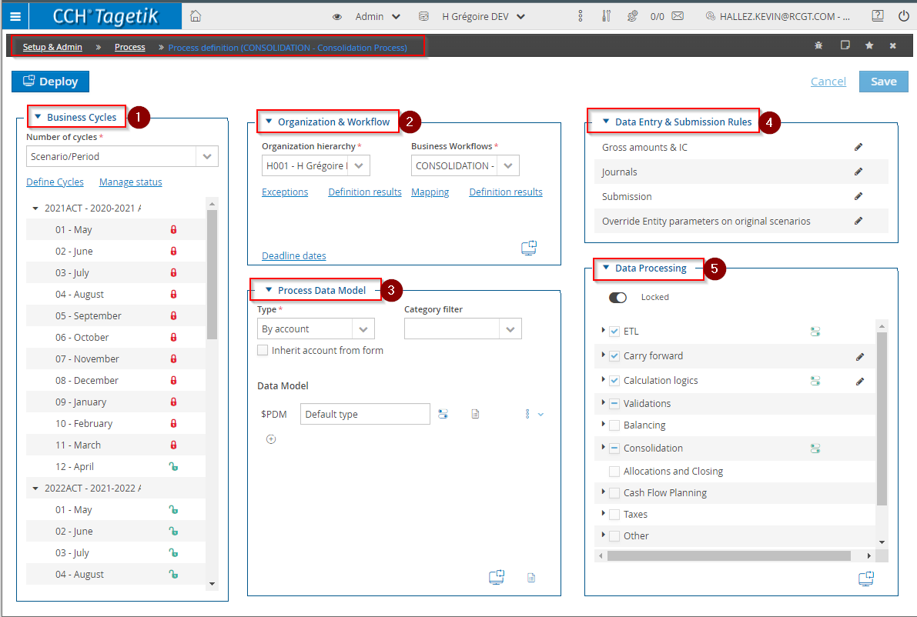
Screenshot 42 - Tagetik Process Console
    - Organization Hierarchy
The organization hierarchy will be the hierarchy on which the contributor’s workflow will be mapped.
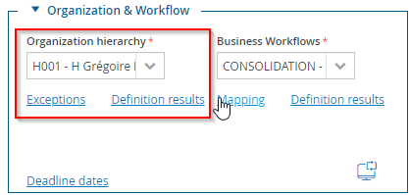
Screenshot 43 - Organization Hierarchy (1)
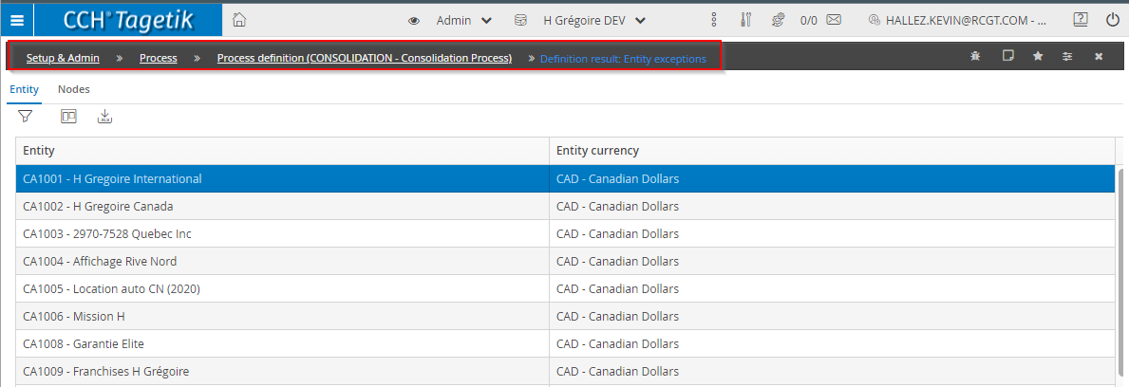
Screenshot 10 - Organization Hierarchy (2)
    - Business Workflows
A Business Workflow allows splitting the application process and the calculation of data into several logical steps and each one in a set of activities to be performed in a given order. The usage of a WFM gives two main advantages:
- it simplifies the work of the contributor user
- allows the users, who must supervise the application process, to perform a very accurate check.
A business workflow is a three levels structure:
- Step. A step represents the first level of the process. Generally, the steps are used to separate logically and temporarily the various moments (or models) of the process. For example, in a statutory consolidation process you may need to collect and submit at different times Original Amounts and Journals and then define a third step for the collection of additional notes data. On the other hand, in a Budget process it may be useful to separate the collection of revenues, of structural costs, of the investments and of the personnel costs from each other.
- Task Workflow. For each step, it is possible to define one or more Task workflows. A task workflow is a set of activities (tasks) which have to be performed in a given order so as to submit data correctly. It is possible to create several task workflows according to the calculation models or to needs of the various entities of the group. Tagetik provides, for each step, two task workflows
- Task. A task represents the single activity to be run. For example, in a payroll application process task flowchart, the compilation of each data entry form represents one task.
Once the setup of the workflow is complete in the set-up & admin, it can be added in the process and mapped for each entity as follows:
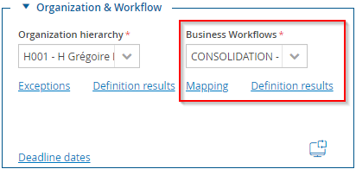
Screenshot 44 - Access to Business Workflow
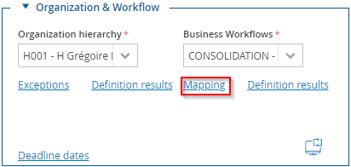
Screenshot 45 - Workflow Mapping (1)
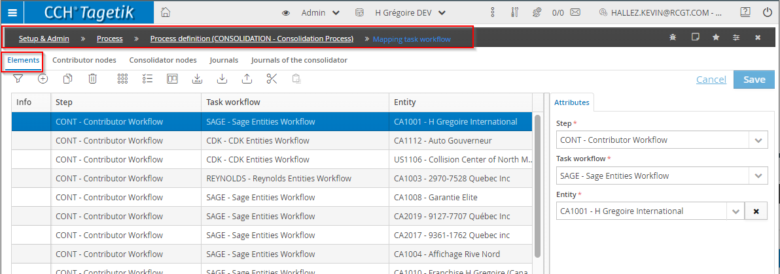
Screenshot 46 - Workflow Mapping (2)
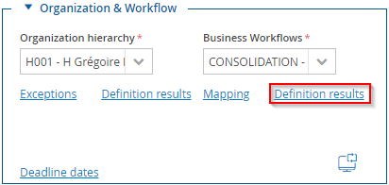
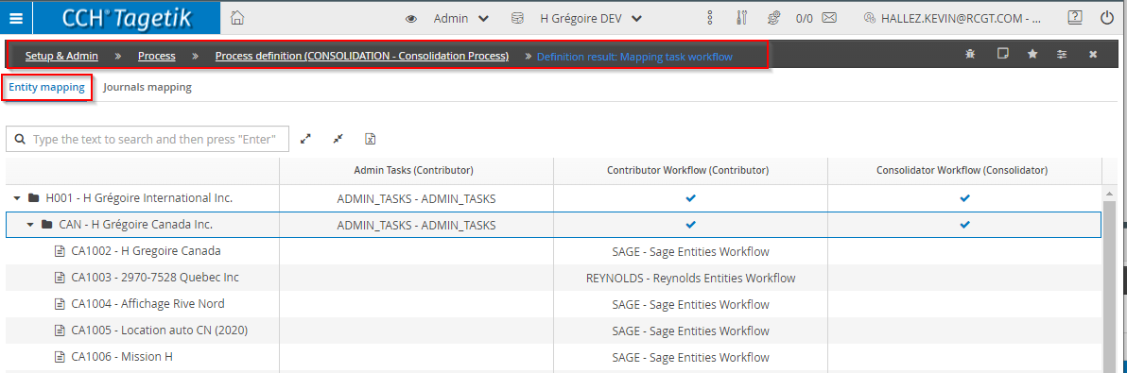
Screenshot 47 - Workflow definition results
    - Process Data Model
When parameterizing a process, it is necessary to define the subset of accounts and categories on which data must be inserted and / or the data processing has to be run, and which are subject to the submission operations. This definition can be done by using Process Data Model.
Within the PDM, it is possible to define the accounts / categories and the measures (custom fields of the datasets) involved in the process, as well as overrides / exceptions, such as:
- to override the editability of a given account / category
- to exclude one or more control groups from a given step
- to include / exclude one or more forms into a given step
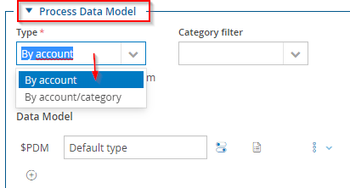
Screenshot 48 - Process Data Model
    - Data Entry & Submission Rules
The data entry and submission rules allow the administrator to set the rules related to data import, IC declaration and IC matching.
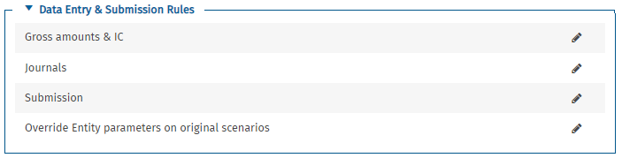
Screenshot 49 - Data Entry & Submission Rules
    - Data Processing
Data processing is where the calculation logics, ETLs, data entry forms are enabled on the process. This is also where consolidation rules are added to the process.
The “Consolidation” section is important as this is where the consolidation areas are set up and this also where the NER is added for new scenarios.
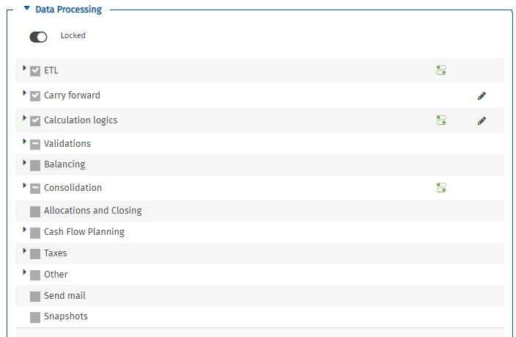
Screenshot 50 - Data Processing
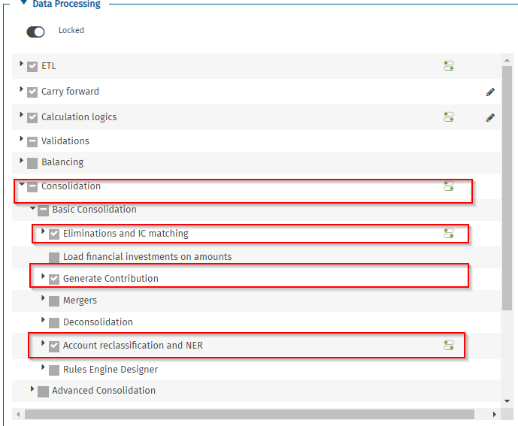
Screenshot 51 - Consolidation Data Processing
- Maintenance of the Contributor’s Workflow
  - Overview
The contributor’s workflow refers to all the steps and tasks required to input the financial packages ahead of the consolidation.
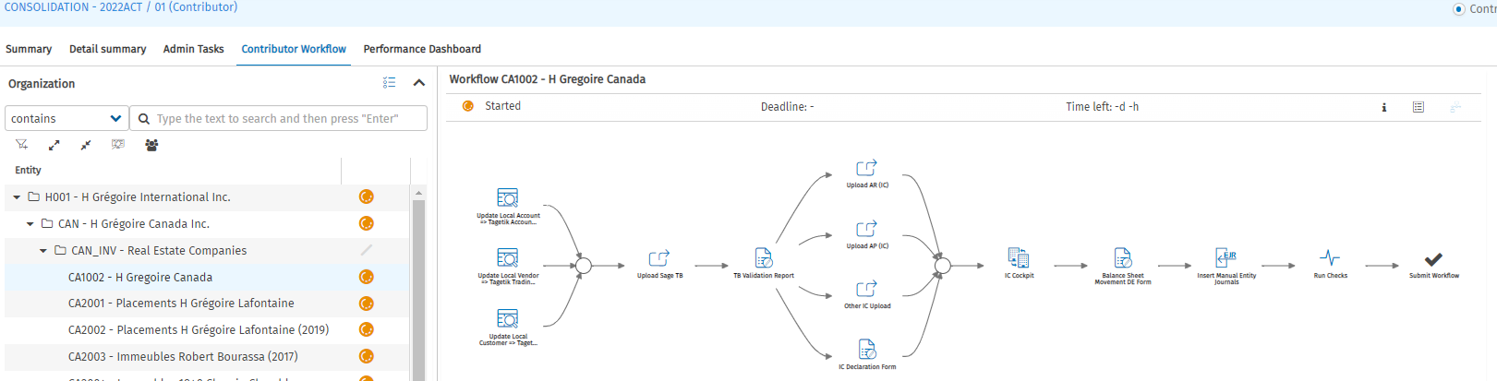
Screenshot 52 - Overview contribution workflow
In the following sections, we will detail the configuration of each of the component of the contribution workflow.
  - Data Origin
Data origin is important in Tagetik, as it tracks how data are input in the system. The following table describe the main data origin that will be present in H Grégoire data tables:
Origin | Description
INPUT_WEB | Manual input - Web windows
INPUT_DEFORM | Manual input - Form
MAP_* | ETL
PROC_IC_BALANCING | IC - automatic balancing
PREL_RESTORE | Original - Restoring
PROC_CTP_ELIMINATIONS | Original - Eliminations for Ctp
PROC_FI_ELIMINATIONS | Original - Eliminate Financial investments from Ownership structure register
PROC_BALANCING | Original - Balancing
PROC_CALCULATED_BASIC | Original - Basic calculation rules
COPY_PERIOD | Original - Carry forward from previous period
QDL | Quick data loader
DEPLOYMENT | Deployments
PREL_COPY_PREVIOUS | Original - Copy from the previous period
PREL_REVERSE1 | Original - Reverse journal 1
PREL_REVERSE2 | Original - Reverse journal 2
PREL_REVERSE3 | Original - Reverse journal 3
PROC_COUNTERPARTY | Original - Create automatic ctps
PROC_FININV_RECL | Original – Financial investments reclassification
PRCO_RESTORE | Consolidation – Carry forward. Derived from PREL_RESTORE on original scenarios
PRCO_RESTORE_MIN | Consolidation - Carry forward - Minorities
CONS_ CONVERSION_CONV | Consolidation – Conversion
CONS_ CONVERSION_DIFF | Consolidation - FX rate differences
CONS_ CONVERSION_ HIST | Consolidation - Conversion at historical FX rate
CONS_ EQUITYEVAL_ CALC | Consolidation - Evaluation with equity method
CONS_MINORITY | Consolidation – Minorities
CONS_ SECTORAL_ RECLASSIFICATION | Consolidation - Look Through - Account reclassification: sectoral
CONS_RECLASSIFICATION | Consolidation - Consolidation reclassification
  - ETL
    - ETL 1: TB Upload from CDK
ETL Factsheet
ETL Domain | 001_TB_CDK
ETL Routine | 10
Entity List
Sample file provided
Target CCH Tagetik Table | DATI_SALDI_LORDI  DATI_SALDI_IC
Input Format | - Excel (xlsx) | ODATA |  | Text delimited/ CSV
Input Format | Tab delimited | Xml |  | Other
Input Format Requirements | Excel upload files need to have a named range: TB
Mapping Tables | - Local Account to Tagetik Account Mapping (From DE99 – Account Mapping Table)
Frequency Upload | Daily | - Monthly |  | Annually
Scheduling Assistant | - No |  | Yes
Data Type | Meta Data | Periodic |  | - Cumulated
Loading Strategy | Append (Insert) | - Delete and insert by  Scenario, Period, Entities
Potential updates of the ETL are:
  - Changes in the Data Source
If the extraction report in CDK changes, the ETL extraction will require rework. For example, if there are new information, attributes to the accounts or date information are added to the extraction, those would need to be added to the ETL logic.
  - Changes in mapping
    - ETL 2: TB Upload from Reynolds
ETL Factsheet
ETL Domain | 001_TB_REYNOLDS
ETL Routine | 10
Entity List
Sample file provided
Target CCH Tagetik Table | DATI_SALDI_LORDI  DATI_SALDI_IC
Input Format | - Excel (xlsx) | ODATA |  | Text delimited/ CSV
Input Format | Tab delimited | Xml |  | Other
Input Format Requirements | Excel upload files need to have a named range: TB
Mapping Tables | - Local Account to Tagetik Account Mapping (From DE99 – Account Mapping Table)
Frequency Upload | Daily | - Monthly |  | Annually
Scheduling Assistant | - No |  | Yes
Data Type | Meta Data | Periodic |  | - Cumulated
Loading Strategy | Append (Insert) | - Delete and insert by  Scenario, Period, Entities
Potential updates of the ETL are:
  - Changes in the Data Source
If the extraction report in Reynolds changes, the ETL extraction will require rework. For example, if there are new information, attributes to the accounts or date information are added to the extraction, those would need to be added to the ETL logic.
  - Changes in mapping

    - ETL 3: TB Upload from SAGE
ETL Factsheet
ETL Domain | 001_TB_SAGE
ETL Routine | 10
Entity List
Sample file provided
Target CCH Tagetik Table | DATI_SALDI_LORDI  DATI_SALDI_IC
Input Format | - Excel (xlsx) | ODATA |  | Text delimited/ CSV
Input Format | Tab delimited | Xml |  | Other
Input Format Requirements | Excel upload files need to have a named range: TB
Mapping Tables | - Local Account to Tagetik Account Mapping (From DE99 – Account Mapping Table)
Frequency Upload | Daily | - Monthly |  | Annually
Scheduling Assistant | - No |  | Yes
Data Type | Meta Data | Periodic |  | - Cumulated
Loading Strategy | Append (Insert) | - Delete and insert by  Scenario, Period, Entities
Potential updates of the ETL are:
  - Changes in the Data Source
If the extraction report in SAGE changes, the ETL extraction will require rework. For example, if there are new information, attributes to the accounts or date information are added to the extraction, those would need to be added to the ETL logic.
  - Changes in mapping

    - ETL 4: IC AP Upload from CDK
This ETL is present in the set-up, but it was decided that it will not be used.
ETL Factsheet
ETL Domain | 002_IC_AP_CDK
ETL Routine | 10
Entity List
Target CCH Tagetik Table | DATI_SALDI_IC
Input Format | - Excel (xlsx) | ODATA |  | Text delimited/ CSV
Input Format | Tab delimited | Xml |  | Other
Input Format Requirements | Excel upload files need to have a named range: IC
Mapping Tables | - Local Vendor to Tagetik CTP Entity
Frequency Upload | Daily | - Monthly |  | Annually
Scheduling Assistant | - No |  | Yes
Data Type | Meta Data | Periodic |  | - Cumulated
Loading Strategy | Append (Insert) | - Delete and insert by  Scenario, Period, Entities
    - ETL 5: IC AP Upload from REYNOLDS
This ETL is present in the set-up, but it was decided that it will not be used.
ETL Factsheet
ETL Domain | 002_IC_AP_REYNO
ETL Routine | 10
Entity List
Target CCH Tagetik Table | DATI_SALDI_IC
Input Format | - Excel (xlsx) | ODATA |  | Text delimited/ CSV
Input Format | Tab delimited | Xml |  | Other
Input Format Requirements | Excel upload files need to have a named range: IC
Mapping Tables | - Local Vendor to Tagetik CTP Entity
Frequency Upload | Daily | - Monthly |  | Annually
Scheduling Assistant | - No |  | Yes
Data Type | Meta Data | Periodic |  | - Cumulated
Loading Strategy | Append (Insert) | - Delete and insert by  Scenario, Period, Entities
    - ETL 6: IC AP Upload from SAGE
This ETL is present in the set-up, but it was decided that it will not be used.
ETL Factsheet
ETL Domain | 002_IC_AP_SAGE
ETL Routine | 10
Entity List
Target CCH Tagetik Table | DATI_SALDI_IC
Input Format | - Excel (xlsx) | ODATA |  | Text delimited/ CSV
Input Format | Tab delimited | Xml |  | Other
Input Format Requirements | Excel upload files need to have a named range: IC
Mapping Tables | - Local Vendor to Tagetik CTP Entity
Frequency Upload | Daily | - Monthly |  | Annually
Scheduling Assistant | - No |  | Yes
Data Type | Meta Data | Periodic |  | - Cumulated
Loading Strategy | Append (Insert) | - Delete and insert by  Scenario, Period, Entities
    - ETL 7: IC AR Upload from CDK
This ETL is present in the set-up, but it was decided that it will not be used.
ETL Factsheet
ETL Domain | 002_IC_AR_CDK
ETL Routine | 10
Entity List
Target CCH Tagetik Table | DATI_SALDI_IC
Input Format | - Excel (xlsx) | ODATA |  | Text delimited/ CSV
Input Format | Tab delimited | Xml |  | Other
Input Format Requirements | Excel upload files need to have a named range: IC
Mapping Tables | - Local Vendor to Tagetik CTP Entity
Frequency Upload | Daily | - Monthly |  | Annually
Scheduling Assistant | - No |  | Yes
Data Type | Meta Data | Periodic |  | - Cumulated
Loading Strategy | Append (Insert) | - Delete and insert by  Scenario, Period, Entities
    - ETL 8: IC AR Upload from REYNOLDS
This ETL is present in the set-up, but it was decided that it will not be used.
ETL Factsheet
ETL Domain | 002_IC_AR_REYNO
ETL Routine | 10
Entity List
Target CCH Tagetik Table | DATI_SALDI_IC
Input Format | - Excel (xlsx) | ODATA |  | Text delimited/ CSV
Input Format | Tab delimited | Xml |  | Other
Input Format Requirements | Excel upload files need to have a named range: IC
Mapping Tables | - Local Vendor to Tagetik CTP Entity
Frequency Upload | Daily | - Monthly |  | Annually
Scheduling Assistant | - No |  | Yes
Data Type | Meta Data | Periodic |  | - Cumulated
Loading Strategy | Append (Insert) | - Delete and insert by  Scenario, Period, Entities
    - ETL 9: IC AR Upload from SAGE
This ETL is present in the set-up, but it was decided that it will not be used.
ETL Factsheet
ETL Domain | 002_IC_AR_SAGE
ETL Routine | 10
Entity List
Target CCH Tagetik Table | DATI_SALDI_IC
Input Format | - Excel (xlsx) | ODATA |  | Text delimited/ CSV
Input Format | Tab delimited | Xml |  | Other
Input Format Requirements | Excel upload files need to have a named range: IC
Mapping Tables | - Local Customer to Tagetik CTP Entity
Frequency Upload | Daily | - Monthly |  | Annually
Scheduling Assistant | - No |  | Yes
Data Type | Meta Data | Periodic |  | - Cumulated
Loading Strategy | Append (Insert) | - Delete and insert by  Scenario, Period, Entities
    - ETL 10: Manual Upload of IC declarations
ETL Factsheet
ETL Domain | 003_IC_STANDARD
ETL Routine | 10
Entity List | ALL
Sample file provided
Target CCH Tagetik Table | DATI_SALDI_IC
Input Format | - Excel (xlsx) | ODATA |  | Text delimited/ CSV
Input Format | Tab delimited | Xml |  | Other
Input Format Requirements | Excel upload files need to have a named range: IC
Mapping Tables | - NA
Frequency Upload | Daily | - Monthly |  | Annually
Scheduling Assistant | - No |  | Yes
Data Type | Meta Data | Periodic |  | - Cumulated
Loading Strategy | Append (Insert) | - Delete and insert by  Scenario, Period, Entities
  - Account Mapping table
The group chart of account described in section 1.2.1, is different to the local chart of accounts used within the individual entities, therefore there is a mapping table that need to be updated when there are new accounts.
This mapping table is used in every TB ETL.
    - Data Entry Form
It was decided that the mapping table management would be easier via an input form. The properties of the DE form are as follows:
Property | Description
Code | DE99
Available on the Workflow | Yes, on the contributor’s workflow
Currency | Not relevant
Prompt Filter | Entity
Entity | The entity selected when launching the data entry form
Local Account | The account code in the ERP system (Source)
Local Account Description | The account description in the ERP system (Source)
Default Tagetik Account | The code of the account we want to map in Tagetik
Default Tagetik Account Sign | Comes from the attributes: "CUSTOM: Accounting Sign" set up in the Account dimension of Tagetik.  - D = Debit  - C = Credit
Alternative Tagetik Account | The code of the account we want to map in Tagetik when the amount is in an opposite sign than the one set in the "CUSTOM: Accounting Sign".
Source Account as Driver | When you want the Local Account to be the driver
Tagetik Account as Driver | When you want the Tagetik Account to be the driver
Trading Partner | When you want to declare an intercompany transaction at the same time

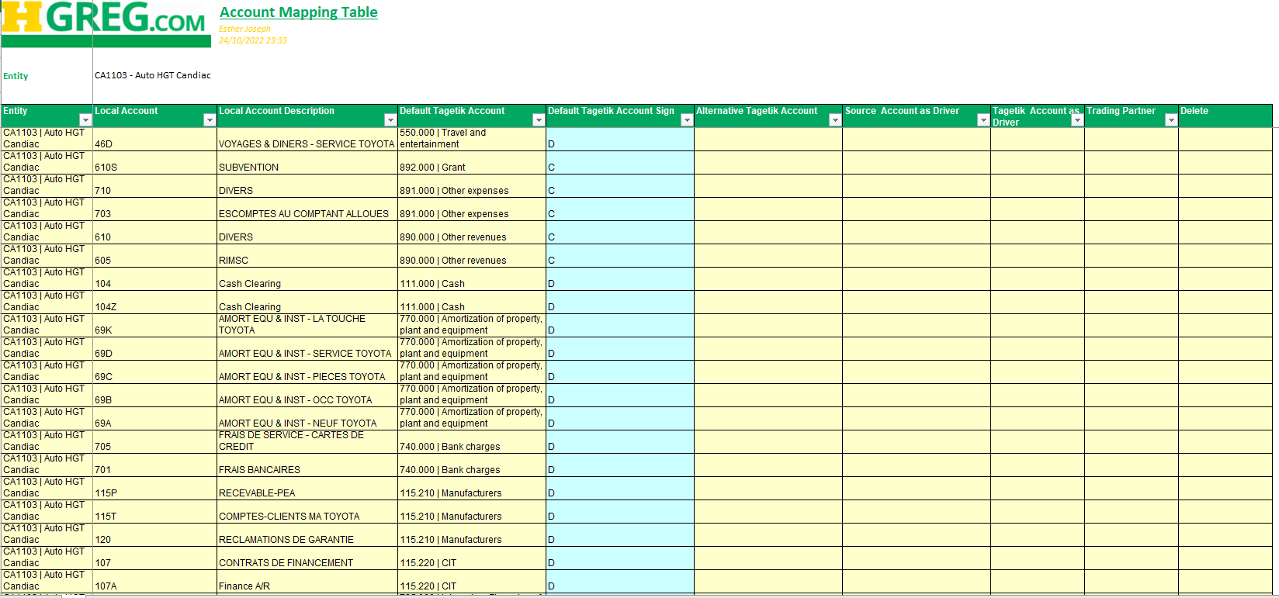
Screenshot 53 - Mapping Table DE Form
The DE form automatically updates the different ETL mapping tables.
  - Balance Sheet Movements
The Balance Sheet Movement refer to the information collected on the variation accounts. This is information is essential for the calculation of the Cash Flow as well as the Continuity Report. There are two options to input that information in Tagetik.
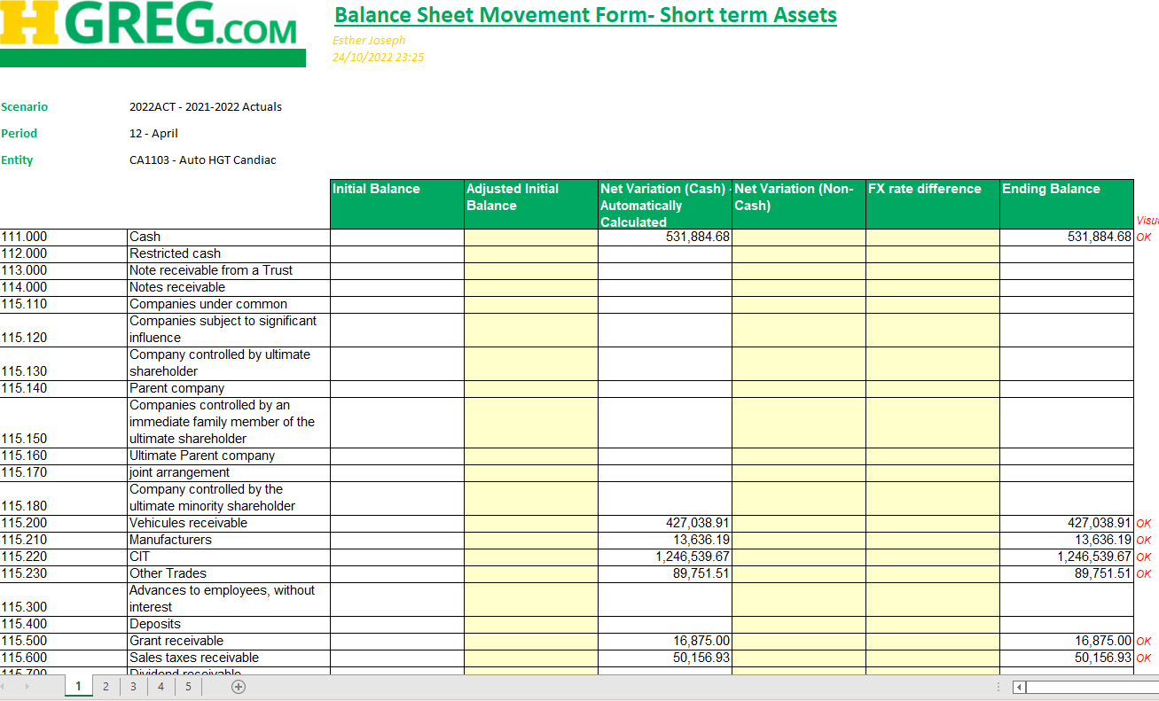
Screenshot 54 - Balance Sheet Movement Form
    - Data Entry Form
The properties of the DE form are as follows:
Property | Description
Code | DE2
Available on the Workflow | Yes, on the contributor’s workflow
Currency | The data must be input on the entity’s currency
Prompt Filter | Original Scenario  Period  Entity
Tabs | Net Variation (Cash) - Automatically Calculated:  The variation accounts are automatically calculated for those accounts. For a particular account, if we do not have a statement on a variation account, the balance of the amount will be automatically calculated in Net Variation (Cash).
Tabs | Net Variation (Non-Cash)  This variation account is used if you do not want to impact the cash flow.
Tabs | Short Term Assets/Short Term Liabilities  The available variations are:  - 110 – Adjusted Initial Balance  - 140 – Net Variation (Cash)  - 150 – Net Variation (Non-Cash)  - 180 – FX rate difference
Tabs | Long Term Assets/Long Term Liabilities  The available variations are:  - 110 – Adjusted Initial Balance  - 120 – Acquisition/Increase  - 130 – Disposal/Decrease  - 140 – Net Variation (Cash)  - 150 – Net Variation (Non-Cash)  - 160 – Changes due to Mergers/Incorportions  - 170 – Reclassification / Transfers  - 180 – FX rate difference
Tabs | Equity  The available variations are:  - 110 – Adjusted Initial Balance  - 120 – Acquisition/Increase  - 130 – Disposal/Decrease  - 140 – Net Variation (Cash)  - 150 – Net Variation (Non-Cash)  - 160 – Changes due to Mergers/Incorportions  - 170 – Reclassification / Transfers  - 180 – FX rate difference
  - Inter Company Transactions Declaration
Intercompany transactions must be added in Tagetik, for the IC elimination to be properly run. The ETL10 detailed in section 2.3.10 can be used to that effect. The following DE form is also an alternative option.
    - Data Entry Form
Screenshot 55 - IC declaration form
Property | Description
Code | DE1
Available on the Workflow | Yes, on the contributor’s workflow
Currency | The data must be input on the entity’s currency
Prompt Filters | Original Scenario  Period  Entity
Tabs | For each IC Account, the TB balance of the account is displayed, and the user can select a trading partner using the (+) button.
Set-up on the Account Dimension | - All IC accounts need to be set up as “IC Management Account”  - All IC accounts need to have their attribute 1 set up as “IC”. This will dynamically update the DE Form.
    - ETL Upload
The ETL10 detailed in section 2.3.10 is designed to collect IC declarations.
  - IC Cockpit
Once all intercompany declarations have been inserted, the reconciliation process begins. The purpose of the reconciliation process is to understand if the intercompany declaration between entities is matched or not.
For that reconciliation to be possible, IC rules are set up and an IC cockpit is also set up.
    - Intercompany Rules
For each logic, the system specifies:
- whether the logic is an IC matching logic and/or a Ctp elimination logic
- the list of primary accounts, specifying if the account belongs to the IC matching logic and/ or to the Ctp elimination logic
- the list of dependent accounts, specifying if the account belongs to the IC matching logic and/ or to the Ctp elimination logic
- the reconciliation accounts
- the categories
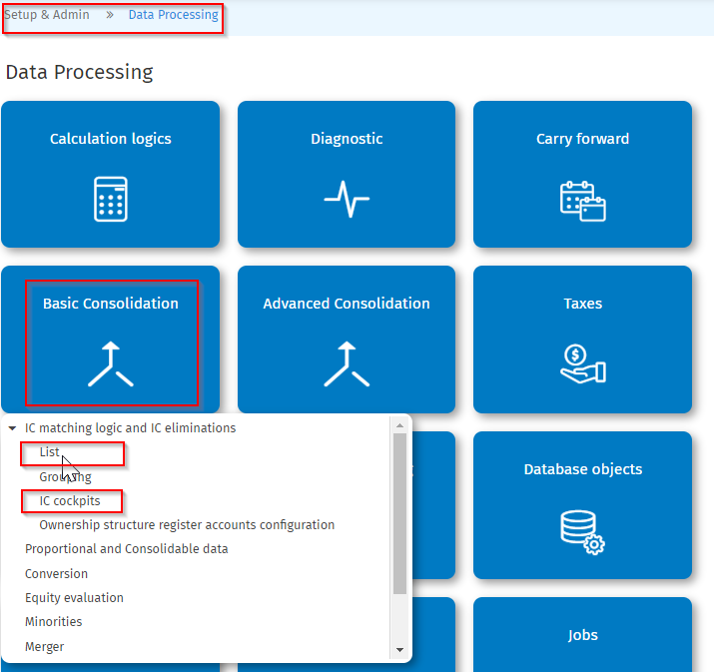
Screenshot 56 - IC rules (1)
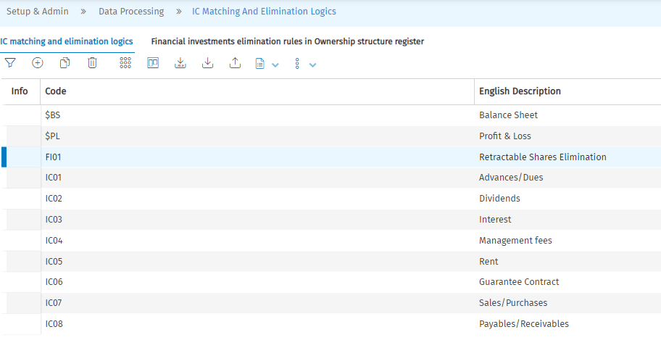
Screenshot 57 - IC Rules (2)
    - Reconciliation Accounts
For every rule, it is possible to add reconciliation accounts that can be used to offset entries used to balance IC declarations.
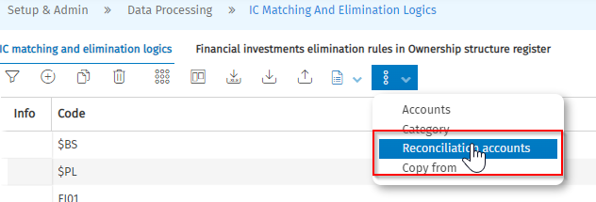
Screenshot 58 - Reconciliation Accounts
The reconciliation accounts can be used to balance the unbalanced declarations. That entry can be traced with the origin and the notes as well as the category “IC_ELIM”.
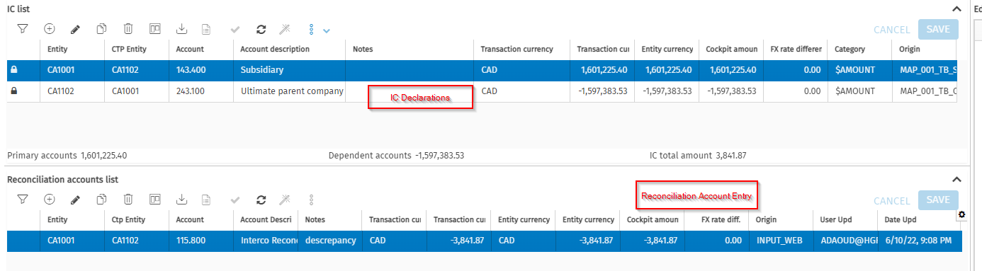
Screenshot 59 - How to use the reconciliation account
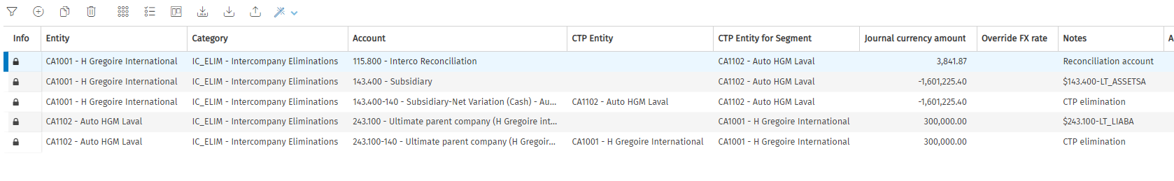
Screenshot 60 - Reconciliation Account on the Elimination Journal
    - Threshold
For every rule, it possible to define a threshold, underneath that threshold, the intercompany can be left as is and the diagnostics will not prevent the submission of that workflow. It is important to enable Auto-Balancing so that the elimination process will balance the elimination journal. 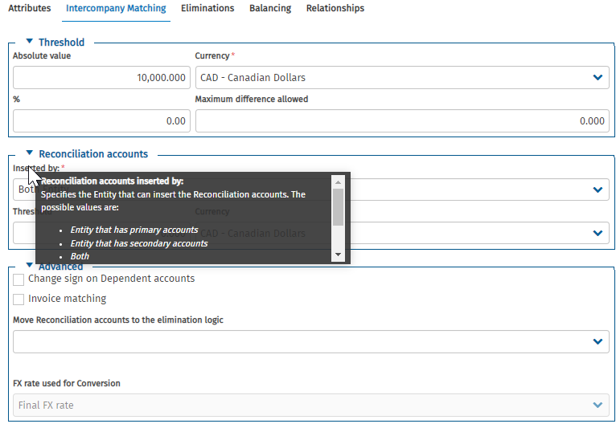
Screenshot 61 - IC Rules (3)
    - Automatic Balancing
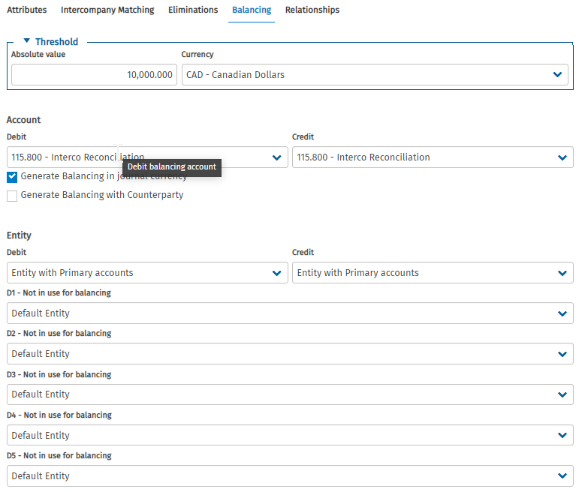
Screenshot 62 - Threshold Elimination
For every rule, it is possible to automate the reconciliation via an automatic balancing. Below a specified threshold, the system will generate an entry on a specified account to balance the unbalanced journal entry. That entry can be traced with the origin and the notes as well as the category “IC_ELIM”.
    - Accounts
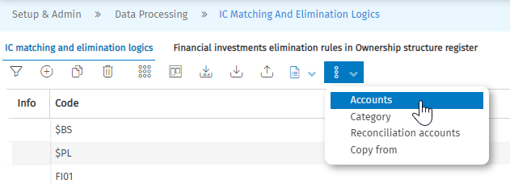
Screenshot 63 - Accounts (1)
In every rule, primary and dependent accounts are added. It is implied that the two sets of accounts need to be offset against each other for the reconciliation process to be complete.
It is possible to only have primary accounts in a rule. In this case, the elimination should add a counterparty row to balance the journal entry.
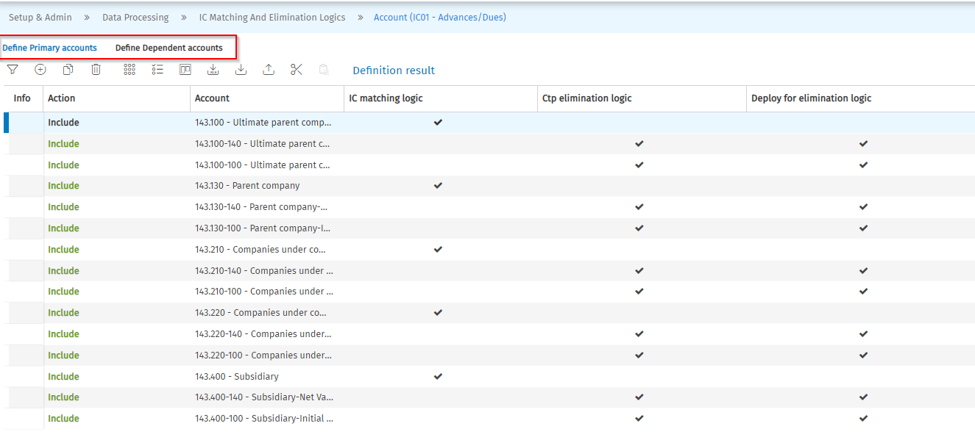
Screenshot 64 - Accounts (2)
    - Categories
It is important to define which data is to be picked up for the reconciliation and elimination process. It is also important to define the category on which the elimination journal will be generated.
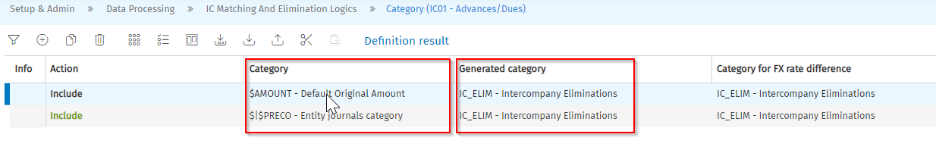
Screenshot 65 - Categories
    - IC Cockpit
Once the IC rules have been set-up, they can be added to an IC Cockpit:
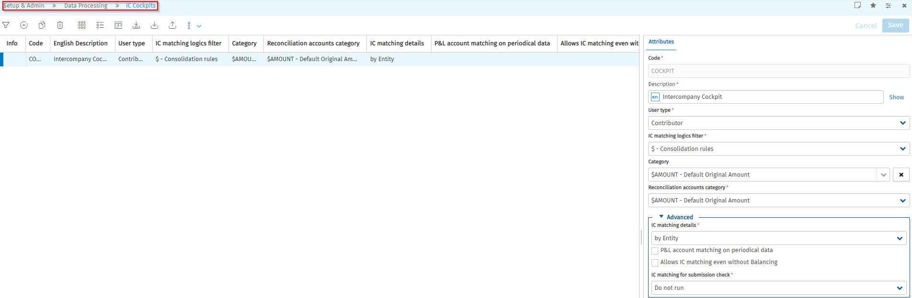
Screenshot 66 - IC cockpit set-up
In the user process, the IC cockpit will look like this:
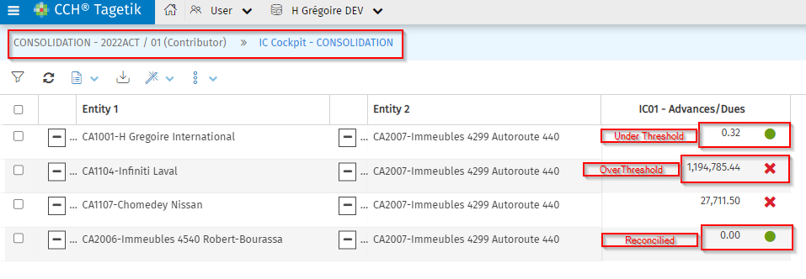
Screenshot 67 - IC cockpit in user setting
If an amount has been manually reconciled with the use of a reconciliation account, the cockpit will showcase this as follows:
Screenshot 68 - IC cockpit with IC Reconciliations
  - Entity Journals
Those journal entries should not be expected to correct accounting posting errors, but rather be used to correct presentation or do other reclassifications.
The journal entries in Tagetik are comprised of two main parts:
- The headers
This is where the user can pick the appropriate category, set a journal number, pick the entity, and the trading partner (CTP entity) where necessary
- The journal rows
This is where the user can input the actual journal. He/she picks
- the account – it is important to note that the user should pick a variation account –
- custom dimensions – it is important to note that the custom dimension not in use (Custom Dimension 3, 4, 5) should be hardcoded to “GEN”
    - Entity Journal Categories
To input journals, the contributor user can use the following categories:
Code | English Description | Category type
ACCT_POLICY | Account Policy Reclass
ENT_ADJ | Other Entity Adjustments | Entity journals
RECLASS | Reclassification | Entity journals

If needed, the administrator, can add additional contributor categories:
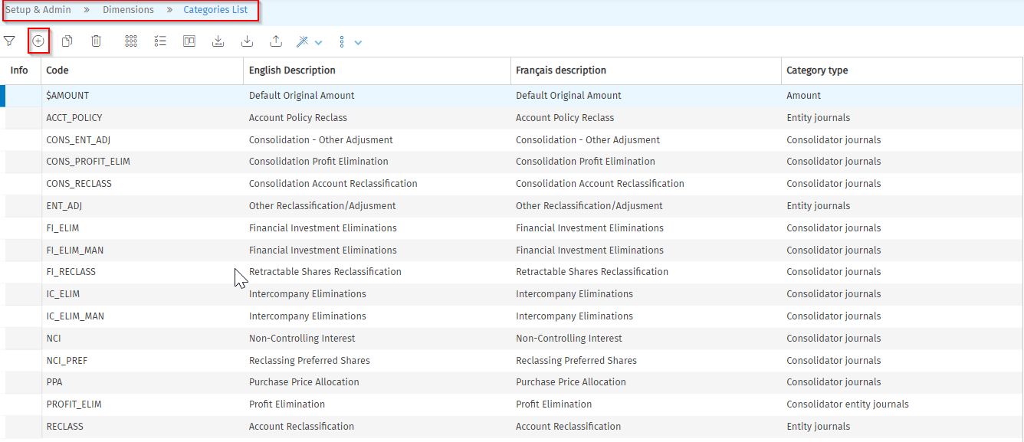
Screenshot 69 - Contributor Journal Categories
  - Diagnostics
The diagnostic is the tool used by users to check the accuracy of collected data in Tagetik. The checks have not been added to the system yet.
- Maintenance of Consolidator’s workflow
  - Consolidation Data Processing
    - Consolidation Area Management
For each consolidation scenario, it is important to set-up the consolidation area. This is done via the process on the admin page:
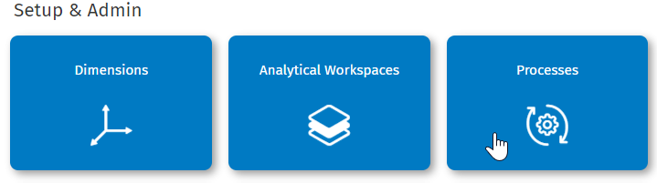
Screenshot 70 - Process Icon
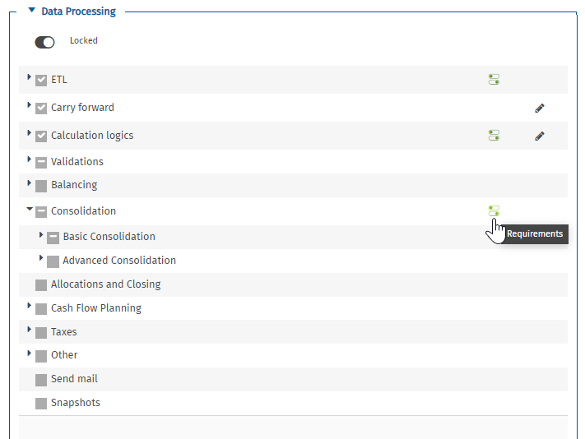
Screenshot 71 - Add Consolidation Area (1)
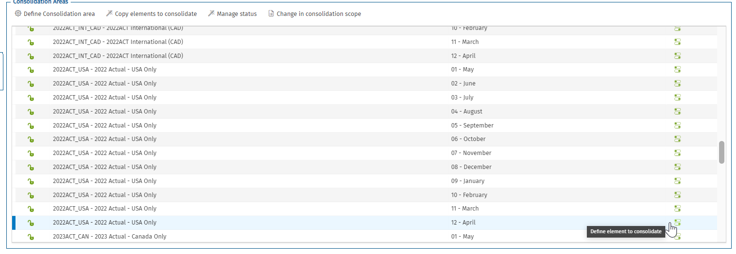
Screenshot 72 - Add Consolidation Area (2)
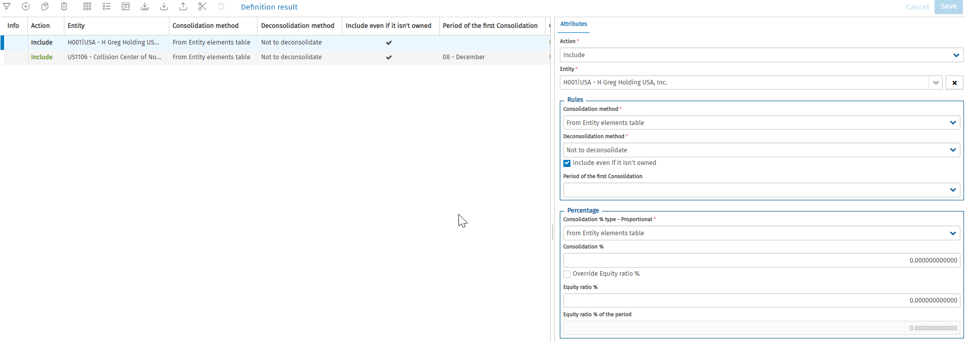
Screenshot 73 - Add Consolidation Area (3)
    - Ownership Structure Register
In addition to the consolidation area, it is important to review the ownership structure register. The OSR drives the financial elimination entries. It works with calendar dates that falls within the calendar dates of the consolidation scenarios.
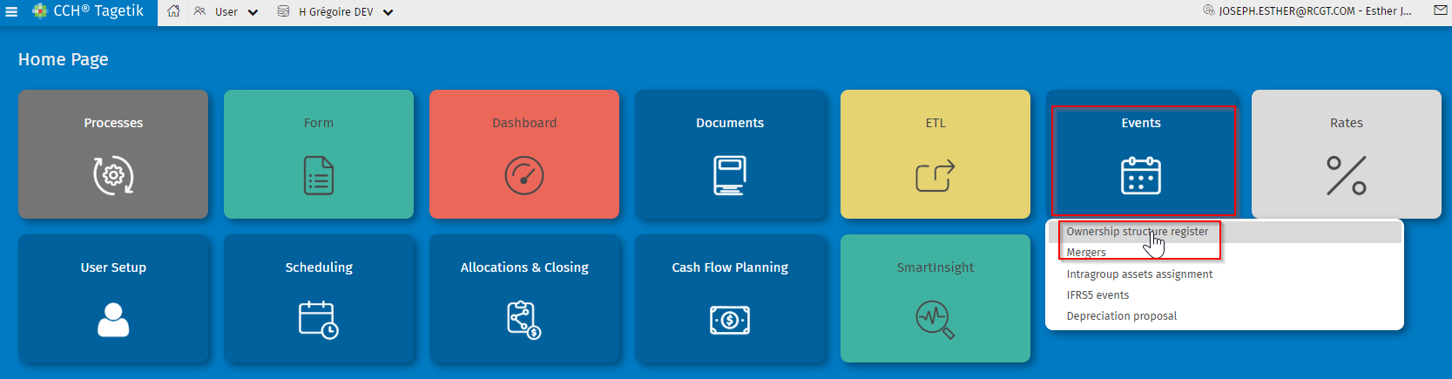
Screenshot 74 - OSR (1)
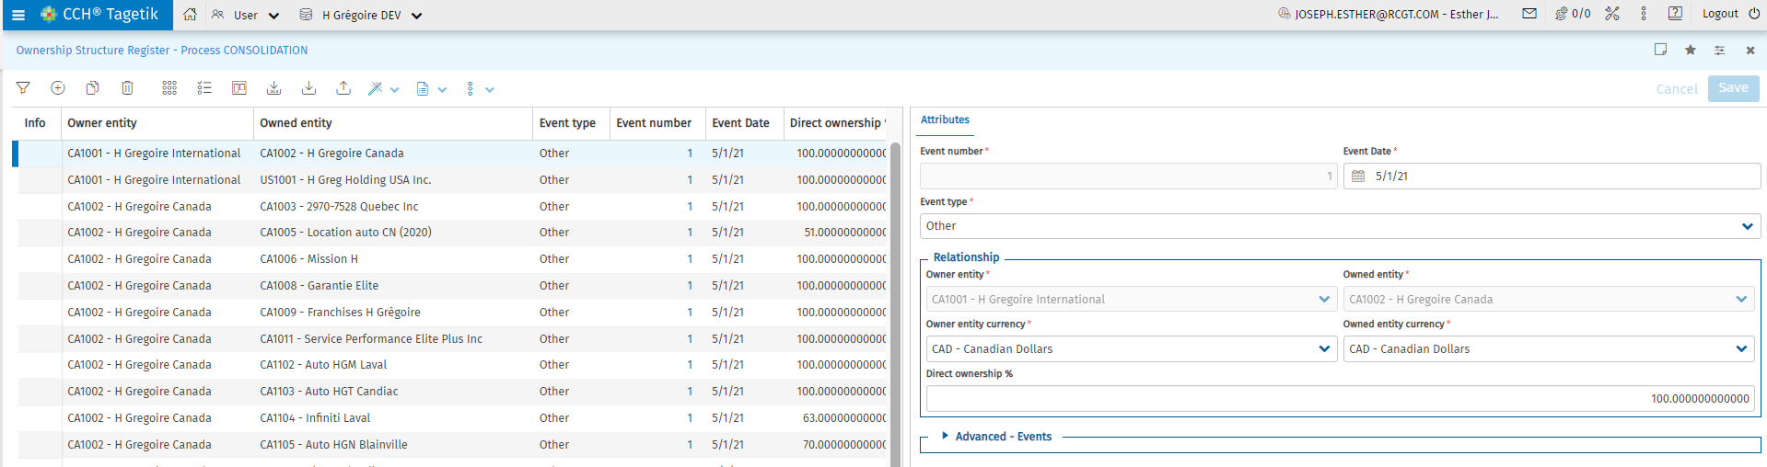
Screenshot 75 - OSR (2)
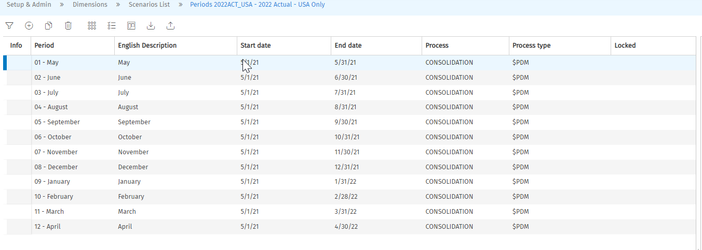
Screenshot 76 - Scenario Calendar dates
In Tagetik the history of the financial investment relationship between the entities of a group, with the related ownerships %, can be managed through the Ownerships structure register. The ownership structure register includes not only the information about the parent entity - child entity relationship, but also the financial information concerning who owns who, the ownership percentage, the carrying value, etc. Data are inserted by financial investment event, namely it is necessary to insert an entry whenever the financial investment relationship changes, for example:
- one share is acquired by minorities
- one share is sold to minorities
- the capital increase is performed, pro quota with the minorities or in different ratios as well
- the minorities perform a capital increase reducing the ownership % of the entity who is inserting data.
- the owner entity depreciates or reevaluates its own F.I.
In the ownership structure register three data types are managed:
- the F.I. relationships with their ownership percentages
- the carrying values of the financial investments for the owner entities (with the related FX rates);
- the net equity values of the owned entities (with the related FX rates)
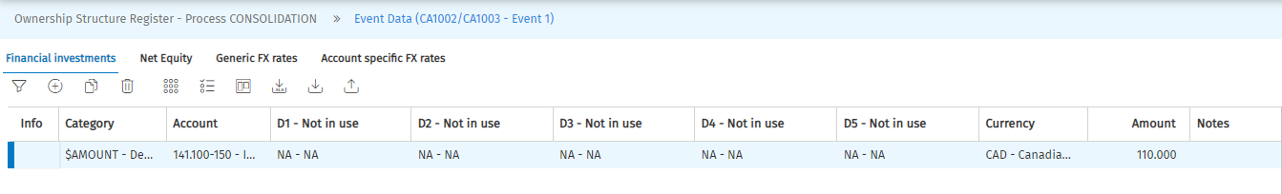
Screenshot 77 - OSR FI elimination entries
    - Financial Investment at H Grégoire
There are several types of shares in the H Grégoire consolidation. The financial investment elimination is different for each of the type of shares. The following summarizes the different approaches:
Source Account | Elimination
280.100 - Ordinary | - Owner Entity should have an investment in the GL 141.100.  Both the GL 141.100 and the GL 280.100 should be eliminated with a Journal Entry generated by the system with a category FI_ELIM. (Documented in the OSR) if the ownership is 100%.  - If ownership < 100%, NCI Journal generated with the GL 280.100 eliminated against the GL 290.000 - Non-controlling interests.
280.200 - Retractable share | Owner Entity should have an investment in the GL 141.100, but the mapping is not precise enough. Therefore, elimination is driven by the GL 280.200. There is an IC Elim that generated an elimination with an automatic balancing with the GL 141.100 with the category FI_RECLASS.
280.300 - Preferred Shares (Non-Participating) | Account Reclassification, the full amount of the GL 280.300 is transferred to the GL 290.000 with the category NCI_PREF.
    - Financial Investment Elimination Rule
For the financial investment elimination, the first step is to identify the GL accounts that are relevant for the rule. They are flagged as accounts “Use account for set up” on the account dimension.
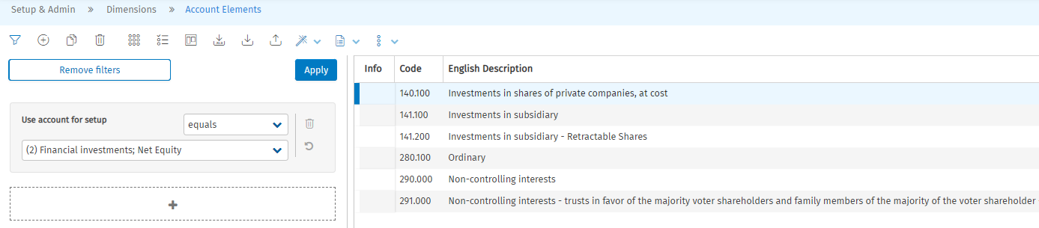
Screenshot 78 - Use account for setup
The following step is to add those accounts to the financial investment rule. The access path is Data Processing > Basic Consolidation > List:
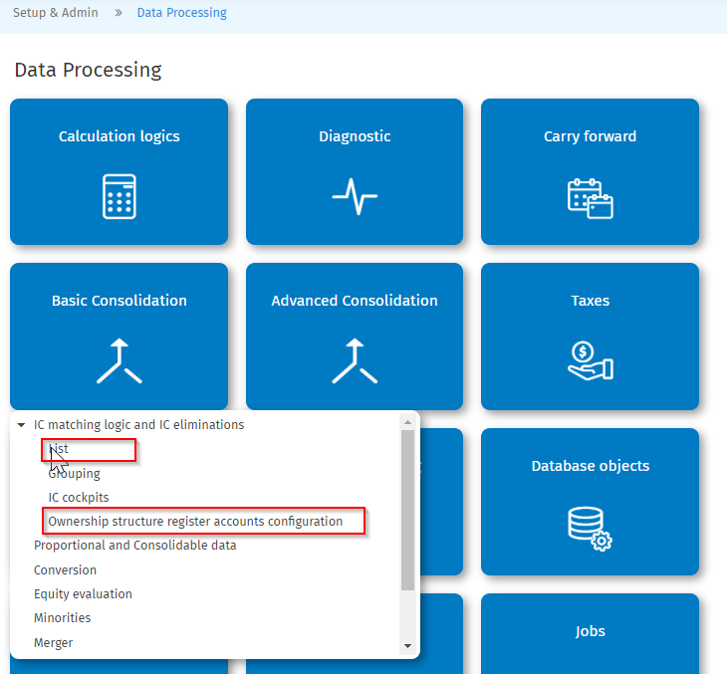
Screenshot 79 - FI Rule Access
On the tab “Financial investments elimination rules in Ownership structure register”, the rule is set up and the attributes, the eliminations and the balancing options are set up.
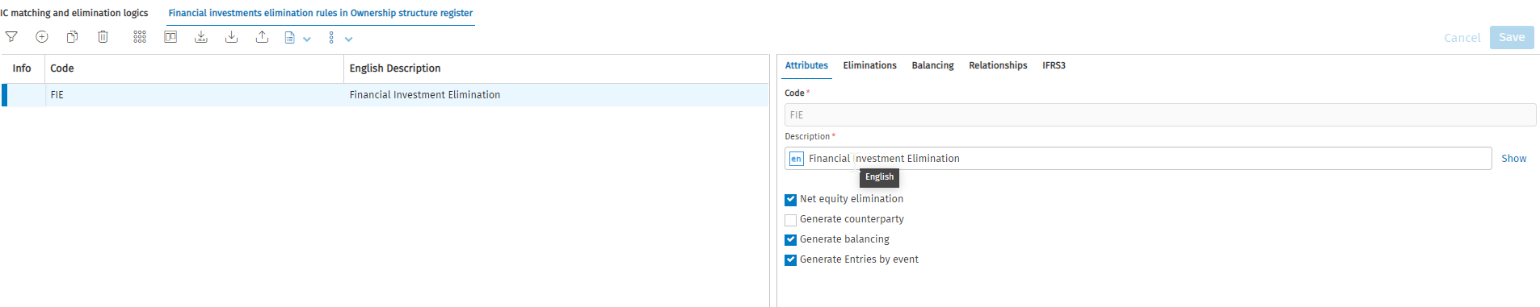
Screenshot 80 - FI rule Attributes
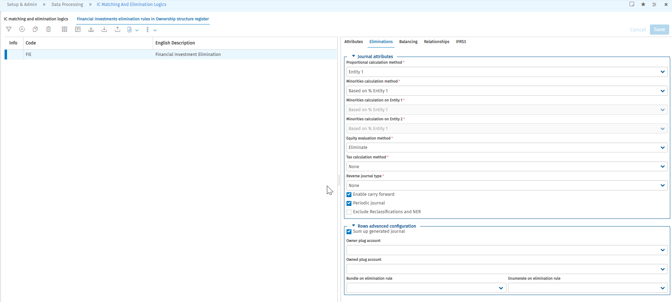
Screenshot 81 - FI rule Eliminations
The accounts are then added:
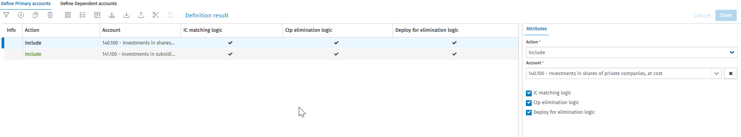
Screenshot 82 - FI accounts
And finally, the categories are added:
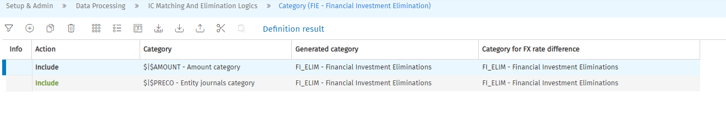
Screenshot 83 - FI Categories
The system will then use the information in the FI Rule as well as the entries in the ownership structure register to generate the elimination journal if the event date falls within the calendar date of the scenario or if the event date is prior to the scenario calendar dates (via the carry forward).
Once the consolidation has been run, the journal entries can be viewed under “Consolidation Journals” in the workflow.
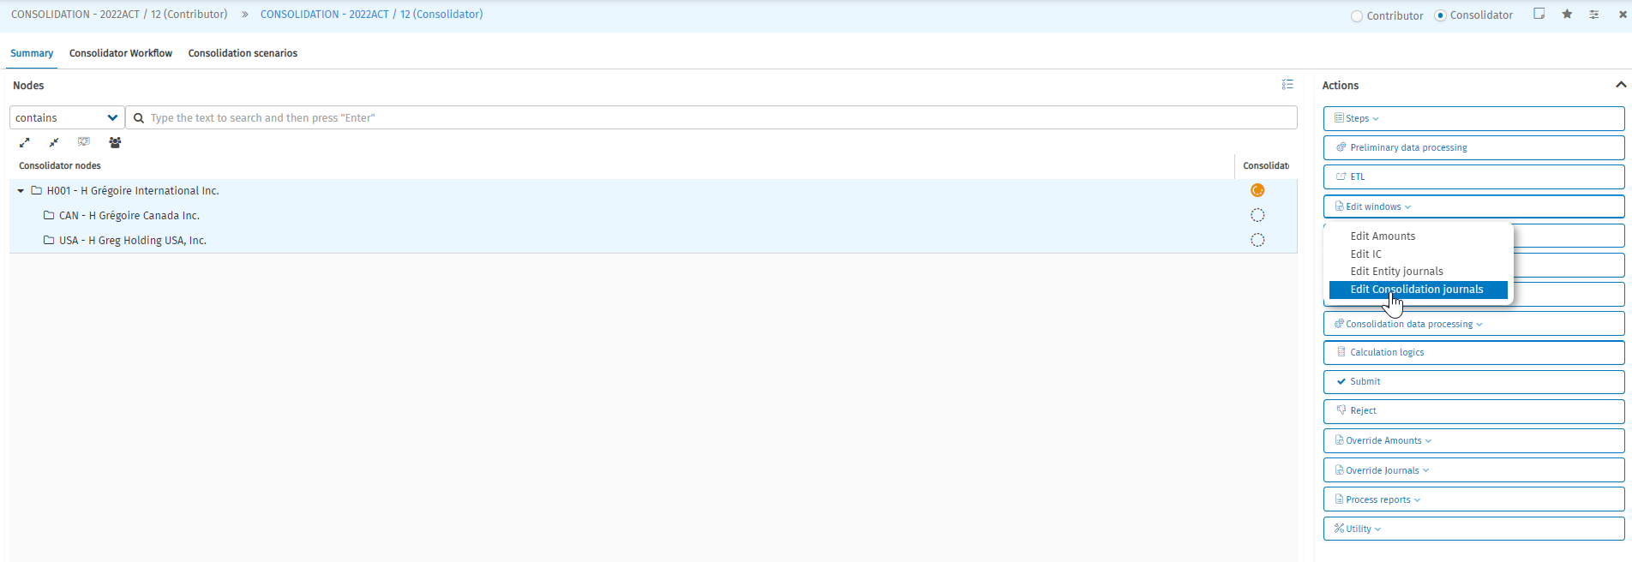
Screenshot 84 - Consolidation Journals on workflow
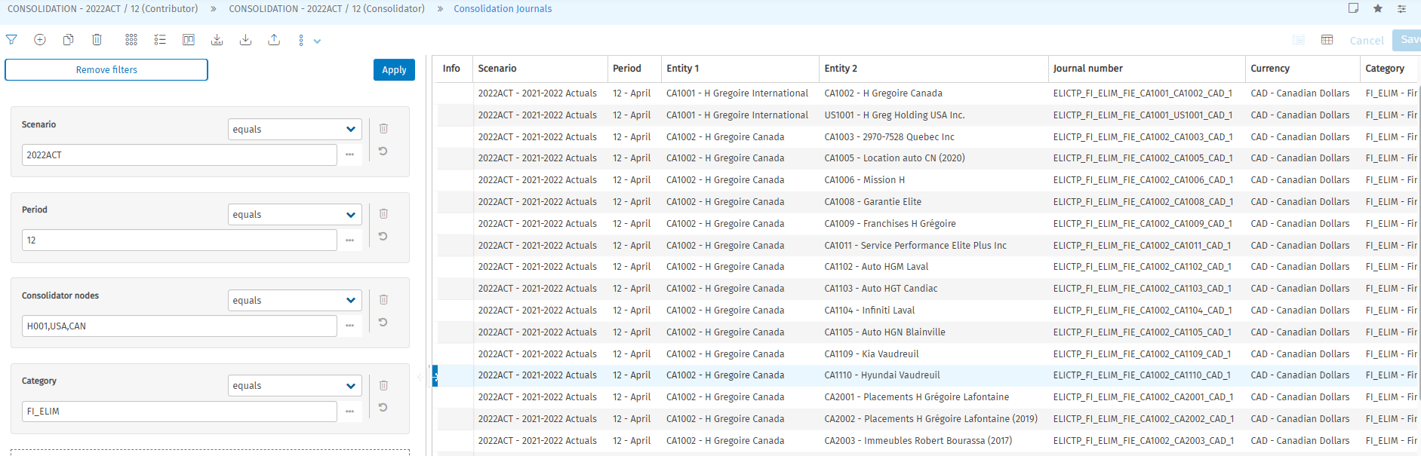
Screenshot 85 - FI Journals
The possible data origins are:
Data origin | Description
PROC_FI_ELIMINATIONS | The “Notes” will further indicate if the amounts relate to:  - Financial Investment  - Equity  - A Balancing  - Goodwill Event or Full Goodwill Event if the IFRS3 is used
PROC_CALCULATED_BASIC | The Elimination journal are set with variation accounts, there is a calculation to generate the amount on the normal account.
PREL_RESTORE | The amounts of the previous P12 of the last scenario is restored to ensure the year-to-date calculation.
    - Non-Controlling Interest Calculation
If the ownership between the holding and the subsidiary, there would be an NCI entry in addition to the FI_ELIM. Only the 280.100 – Ordinary Shares will trigger the NCI calculation and the target account is 290.000 - non-controlling interests.
The set-up of the rule is under: Set-up & Admin > Data Processing > Basic Consolidation > Minorities
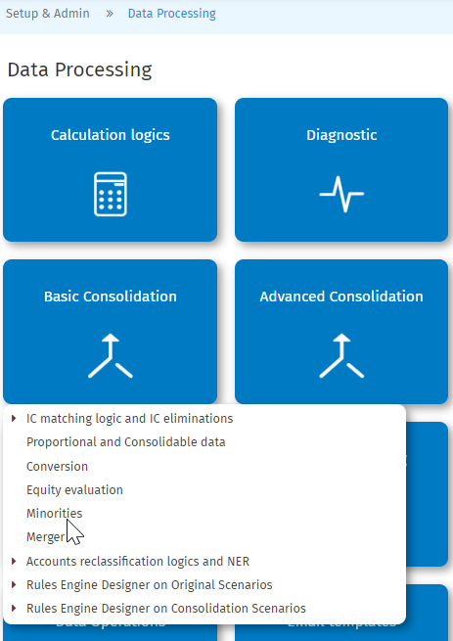
Screenshot 86 - NCI (1)
In the rule, there are source accounts and target accounts as well as source categories and target categories.
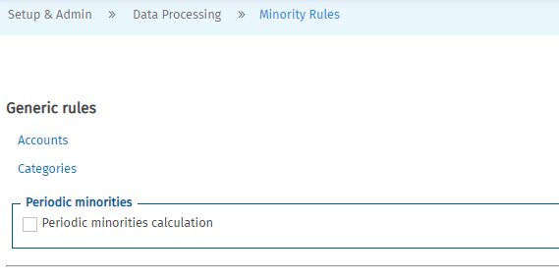
Screenshot 87 - NCI (2)
The source and target accounts are as follows:
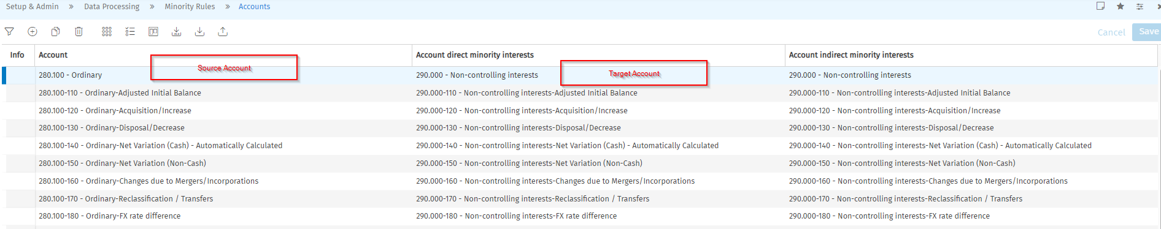
Screenshot 88 - NCI (3)
The source and target categories are as follows:
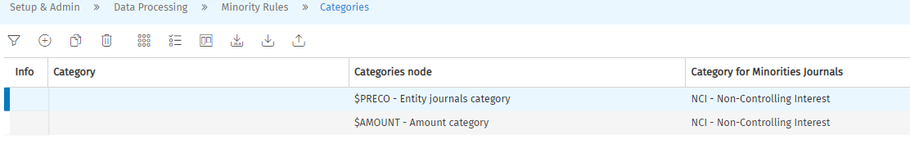
Screenshot 89 - NCI (4)
    - Preferred Shares Reclassification
It was decided that the preferred shares would be eliminated against the non-controlling interest. The set-up is as follows:
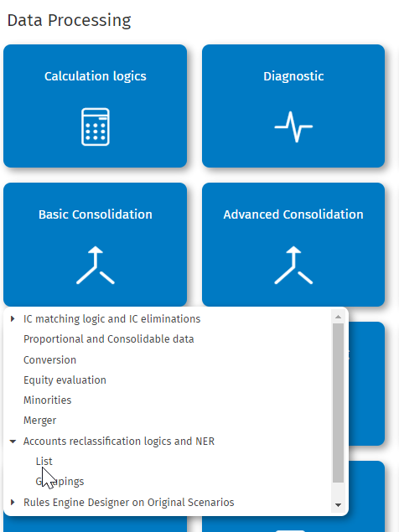
Screenshot 90 - Preferred Shares Reclassification (1)
Similarly, to the other rules, there are source accounts and target accounts as well as source categories and target categories.
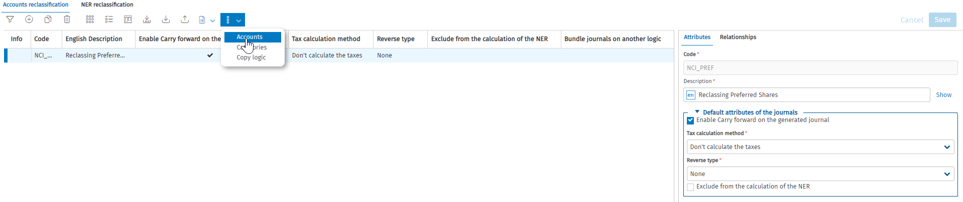
Screenshot 91 - Preferred Shares Reclassification (2)
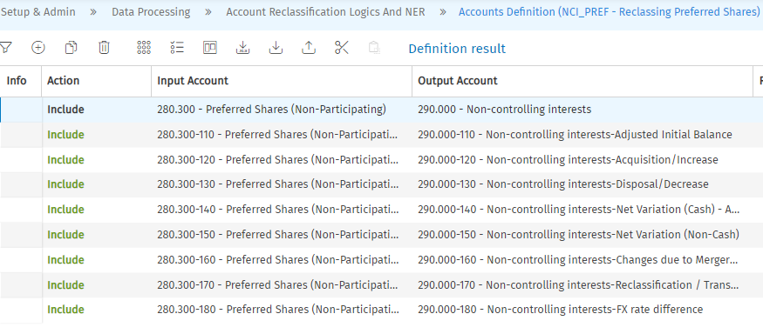
Screenshot 92 - Preferred Shares Reclassification - Source and Target Accounts
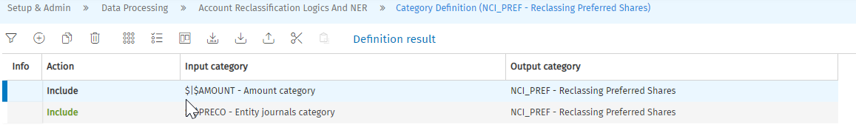
Screenshot 93 - Preferred Shares Reclassification - Source and Target Categories
    - Retractable Shares Elimination
The retractable shares are eliminated using an intercompany elimination rule. The investment is not always booked in the owner entity TB; therefore, the retractable share is the account driving the elimination. Therefore, the elimination would be triggered if there is a declaration, an input on the GL 280.200-140 - Retractable Share-Net Variation (Cash) - Automatically Calculated.
The access path is Setup & Admin > Data Processing > IC Matching and Elimination Logics > F01-Retractable Shares Elimination.
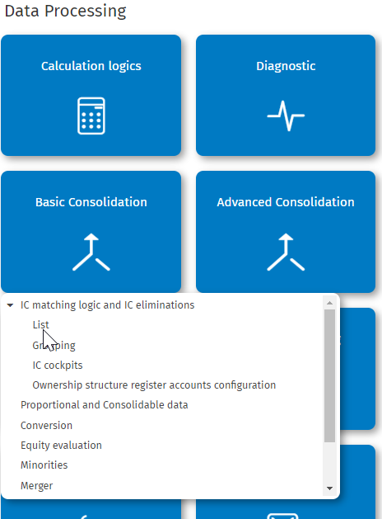
Screenshot 94 - Retractable Shares Elimination (1)
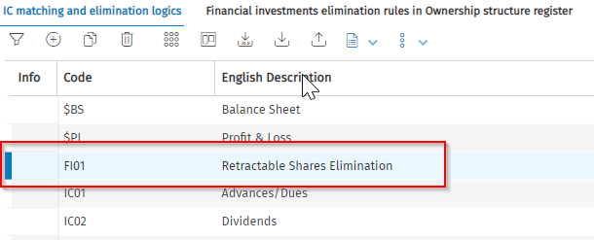
Screenshot 95 - Retractable Shares Elimination (2)
The source account is 280.200-140 - Retractable Share-Net Variation (Cash) - Automatically Calculated.
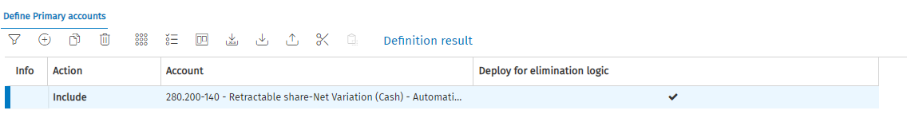
Screenshot 96 - Retractable Shares Elimination - Source Accounts
The rule is set to generate a journal entry and balance the entry against the GL 141.100-140 - Investments in subsidiary-Net Variation (Cash) - Automatically Calculated.
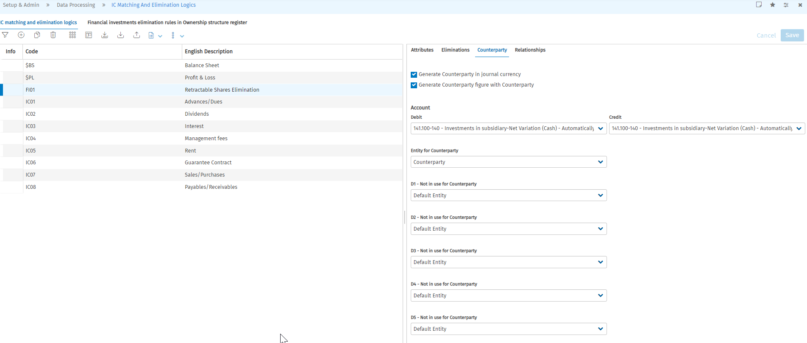
Screenshot 97 - Retractable Shares Elimination – Counterparty
The source and Target Categories are as follows:
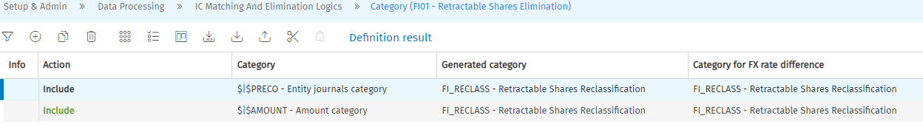
Screenshot 98 - Retractable Shares Elimination - Source and Target Categories
    - Intercompany Elimination Rule
The intercompany elimination is the final step of the Intercompany Process in the system. Once the IC cockpit can be reconciled with:
- Balanced declarations between entities
- Balanced declarations with an input on a reconciliation account
- Unbalanced declarations but under the set thresholds
The system will then generate eliminations for each IC cockpit line, which is essentially the concatenation of the declaring entities and the IC rule code. If the automatic balancing is set up on the IC rule, the system will balance any unbalanced entries.
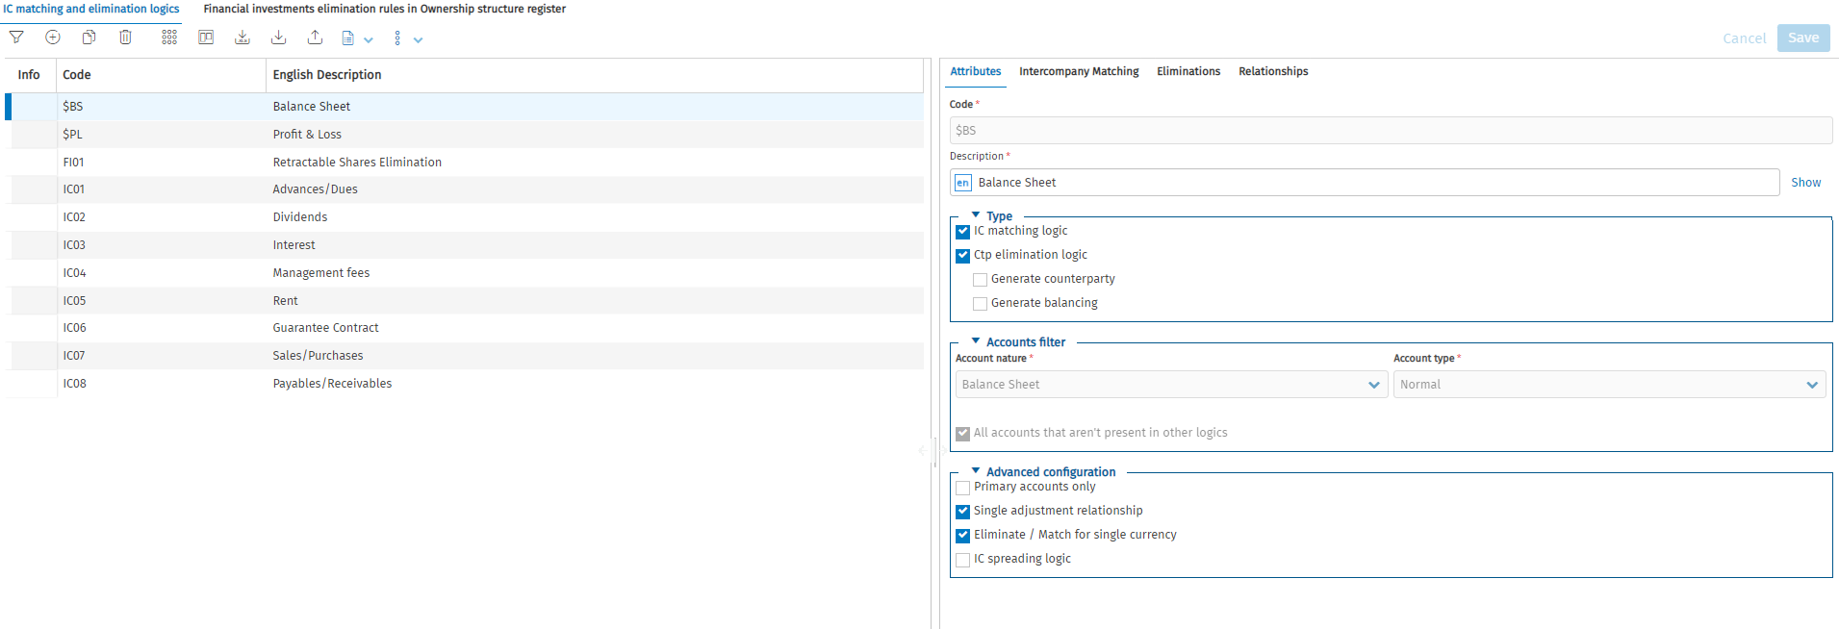
Screenshot 99 - IC Rules
The output category is set to be “IC Elim” and the elimination journal entries are visible under “Consolidation Journals” in the workflow.
Screenshot 100 - Consolidation Journals on workflow
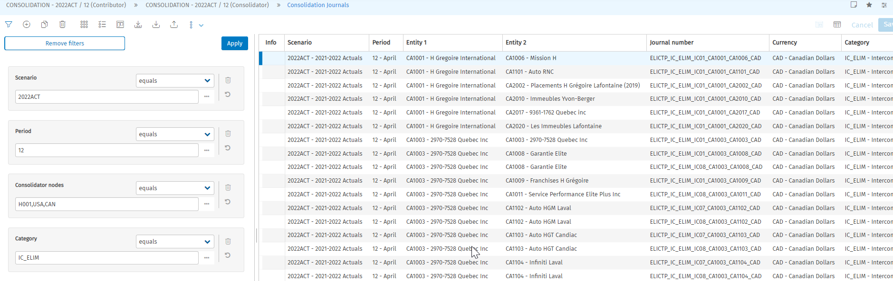
Screenshot 101 - IC elimination entries
The possible data origins are:
Data origin | Description
PROC_CTP_ELIMINATIONS | The “Notes” will further indicate if the amounts relate to:  - An automatic offset  - A Balancing  - A CTP elimation  - FX rate diff calculation
PROC_CALCULATED_BASIC | The Elimination journal are set with variation accounts, there is a calculation to generate the amount on the normal account.
PREL_RESTORE | The amounts of the previous P12 of the last scenario is restored to ensure the year-to-date calculation.

    - Currency Conversion Rule
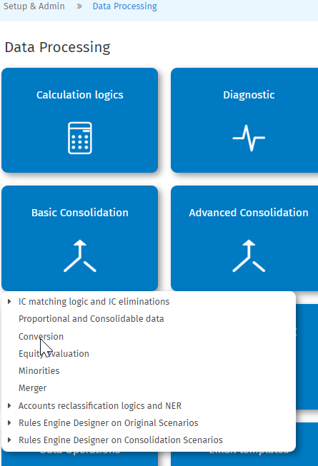
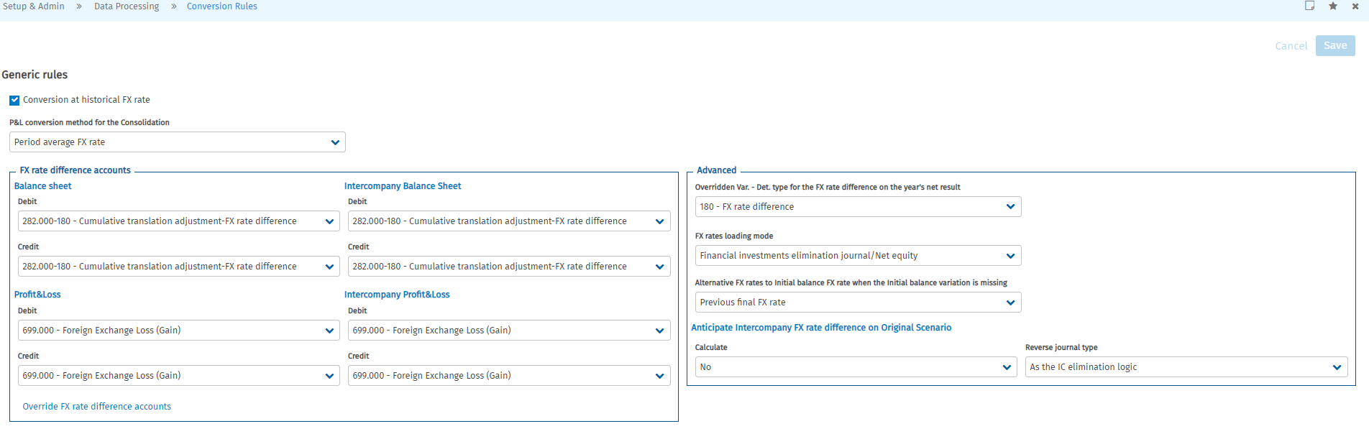
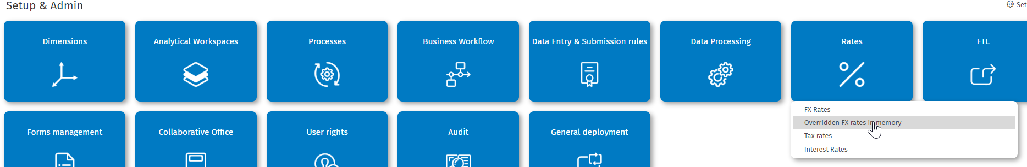

  - Consolidation Validation Reports
    - Consolidation Validation Report
Property | Description
Code | CONS1
Available on the Workflow | No
Currency | Consolidation Currency
Prompt Filters | Consolidation Scenario  Period  Entity
Tabs | 1: Consolidated Profit & Loss Statement  2: Consolidated Balance Sheet

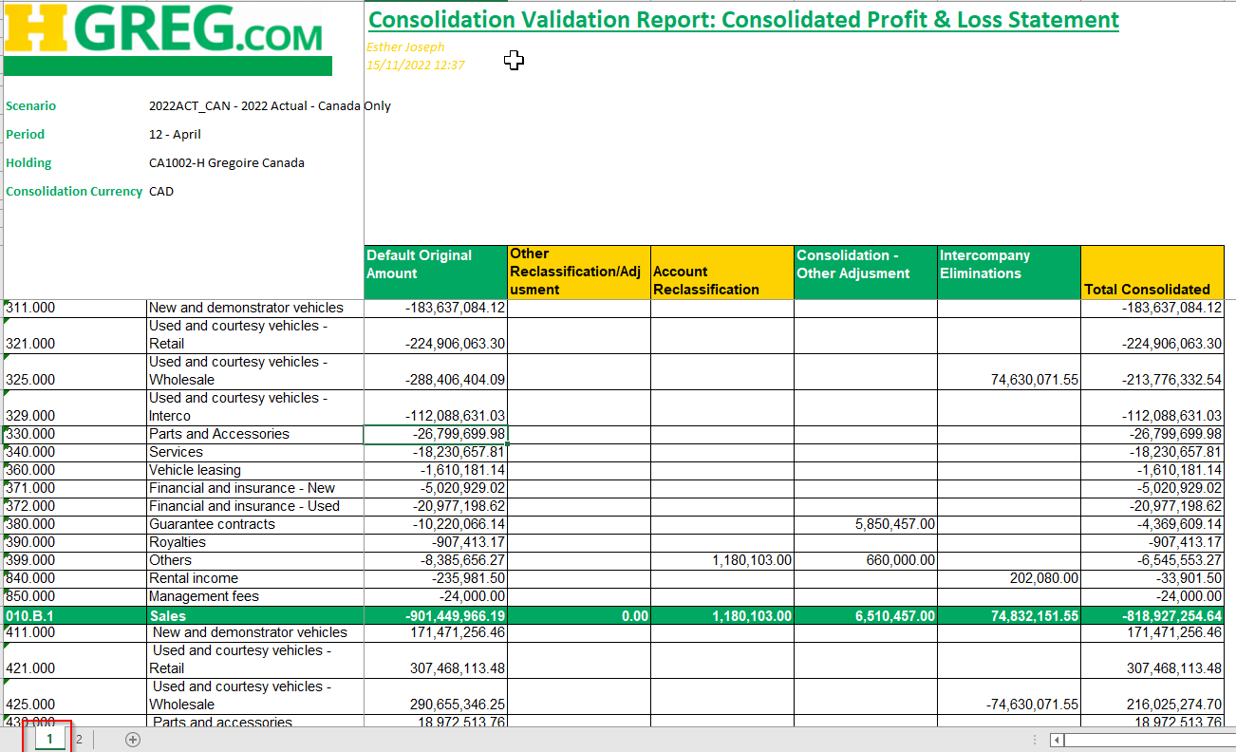
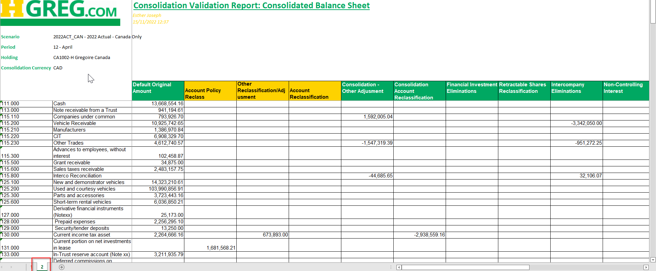

Tagetik Online Help
Tagetik Online Help
Tagetik Online Help
Tagetik online help
Tagetik online help
Tagetik Help Center
Tagetik Help Center

